**Advanced Web Programming – Model and Eloquent Model**

**Week 4**



**Baskoro Seno Aji**

**2341720063 / 05 / TI-2I**

**Github Link :** [**Github**](https://github.com/Anothaatype/University/tree/main/Semester-4/Pemrograman-Web-Lanjut/Week-3/PWL_POS)

**Polytechnic State of Malang**

**Properties of $fillable and $guarded**

**Praktikum 1 - $fillable and $guarded**

1. 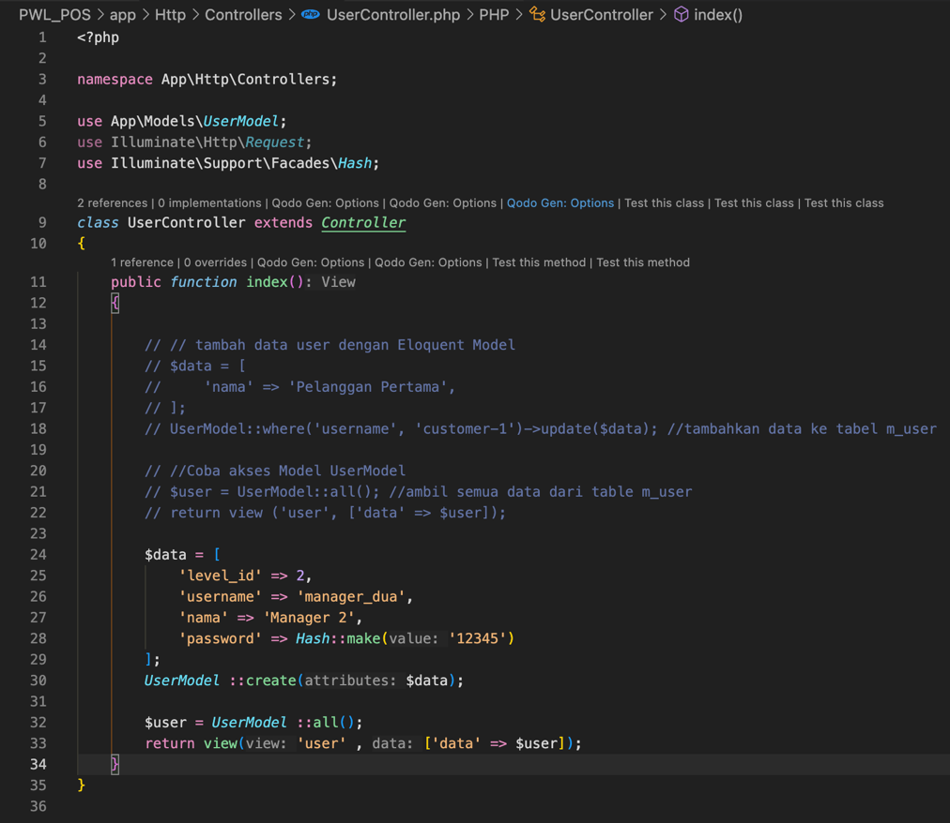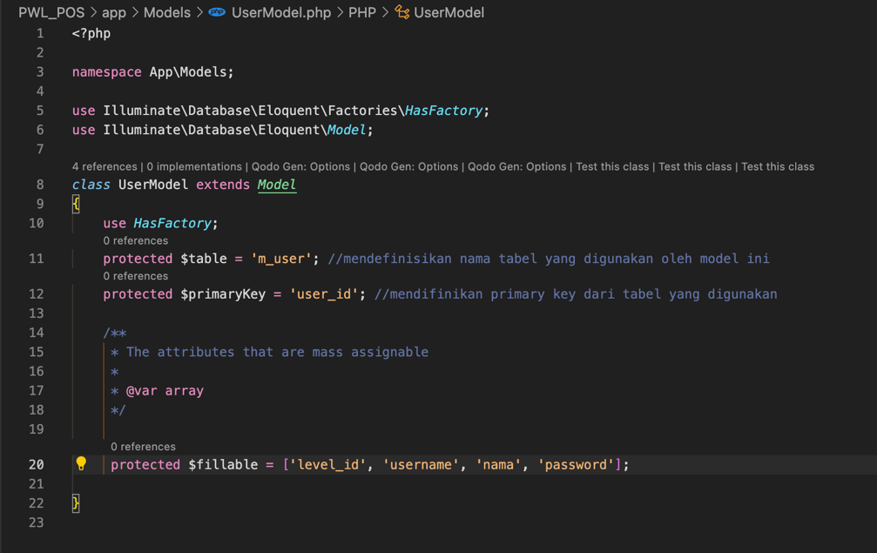**Steps 1 and 2 :**

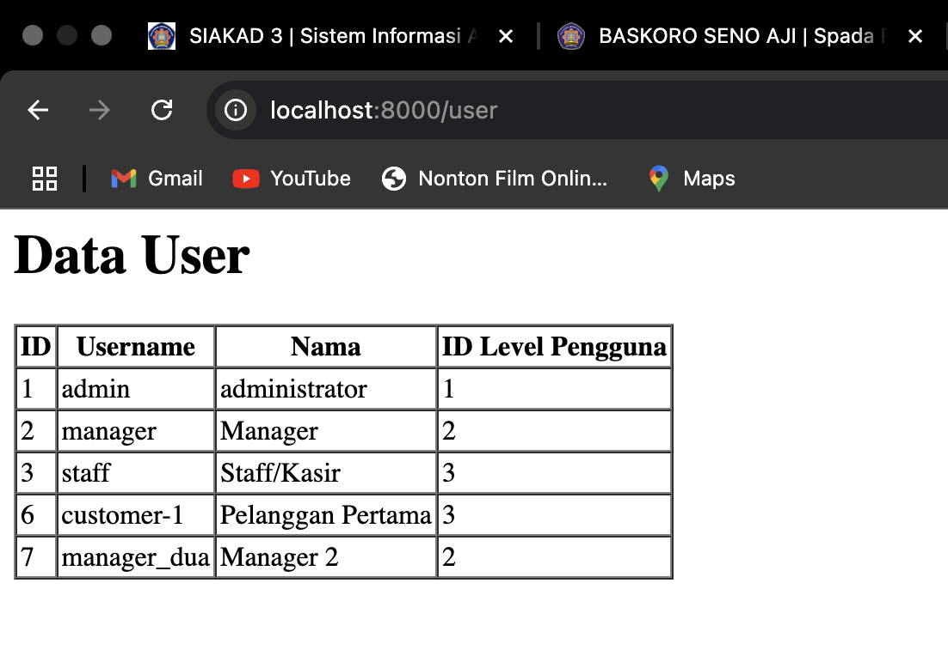

1. In this case we’re implementing the $Fillable where we insert the username, name and also the ID Level pengguna into the table and it’s already included in the table
2. 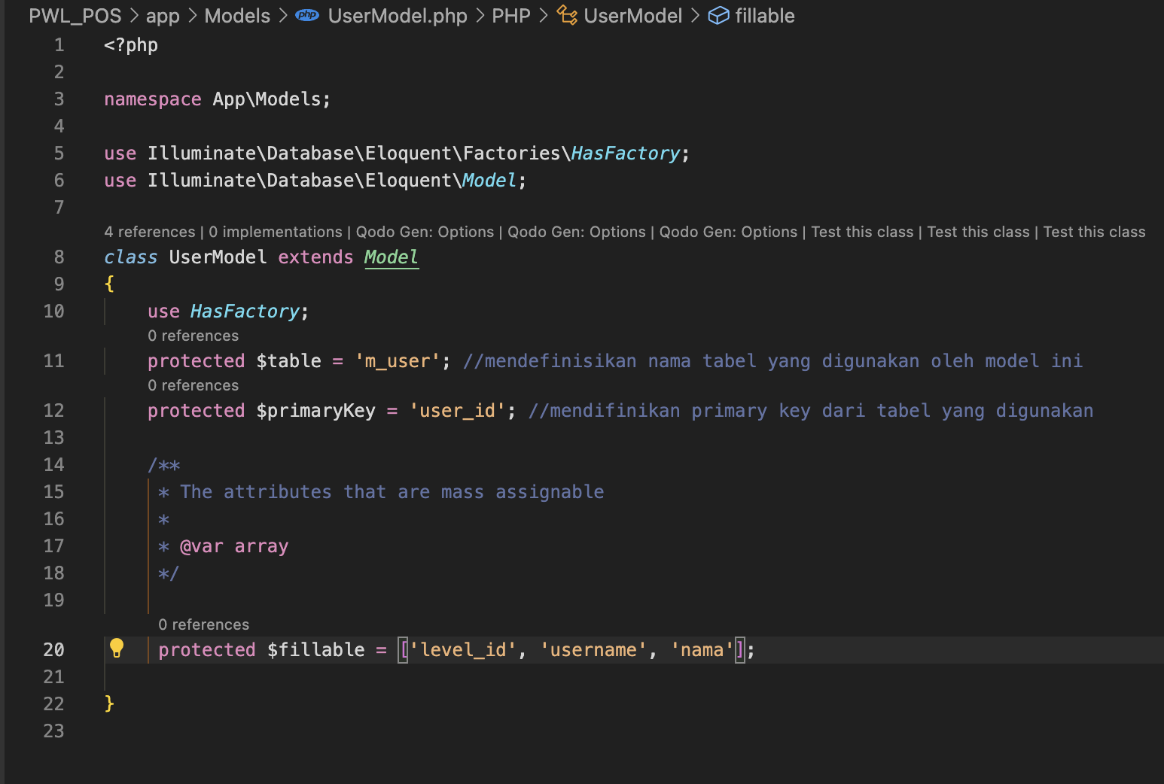**Step 4 and 5 :**

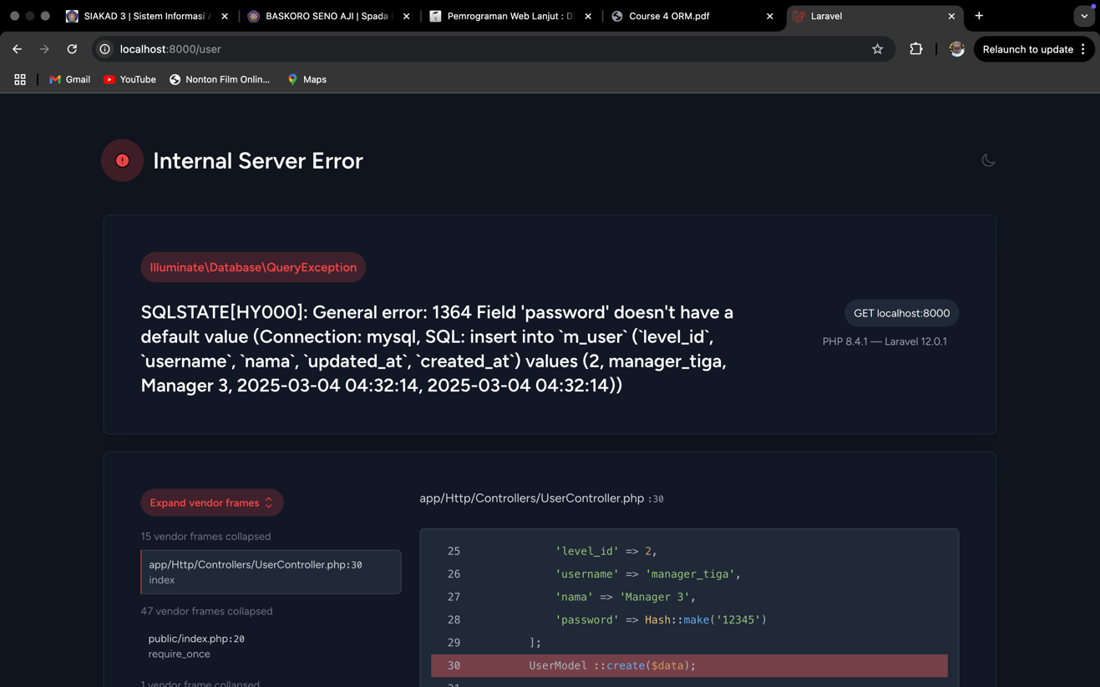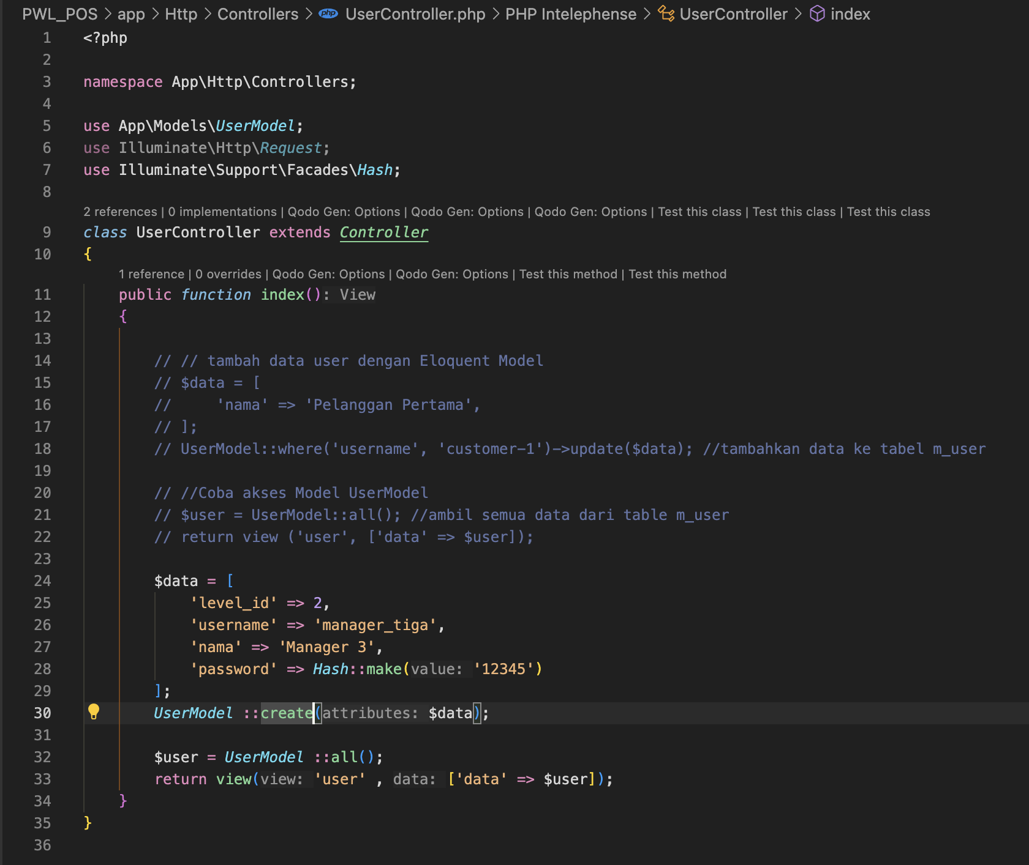

1. In this part the output is error because of we erase the password variable in the user model inside the protected value. So the public function index variable can’t be access

**Retrieving Single Models**

**Praktikum 2.1 Retrieving Single Models**

1. 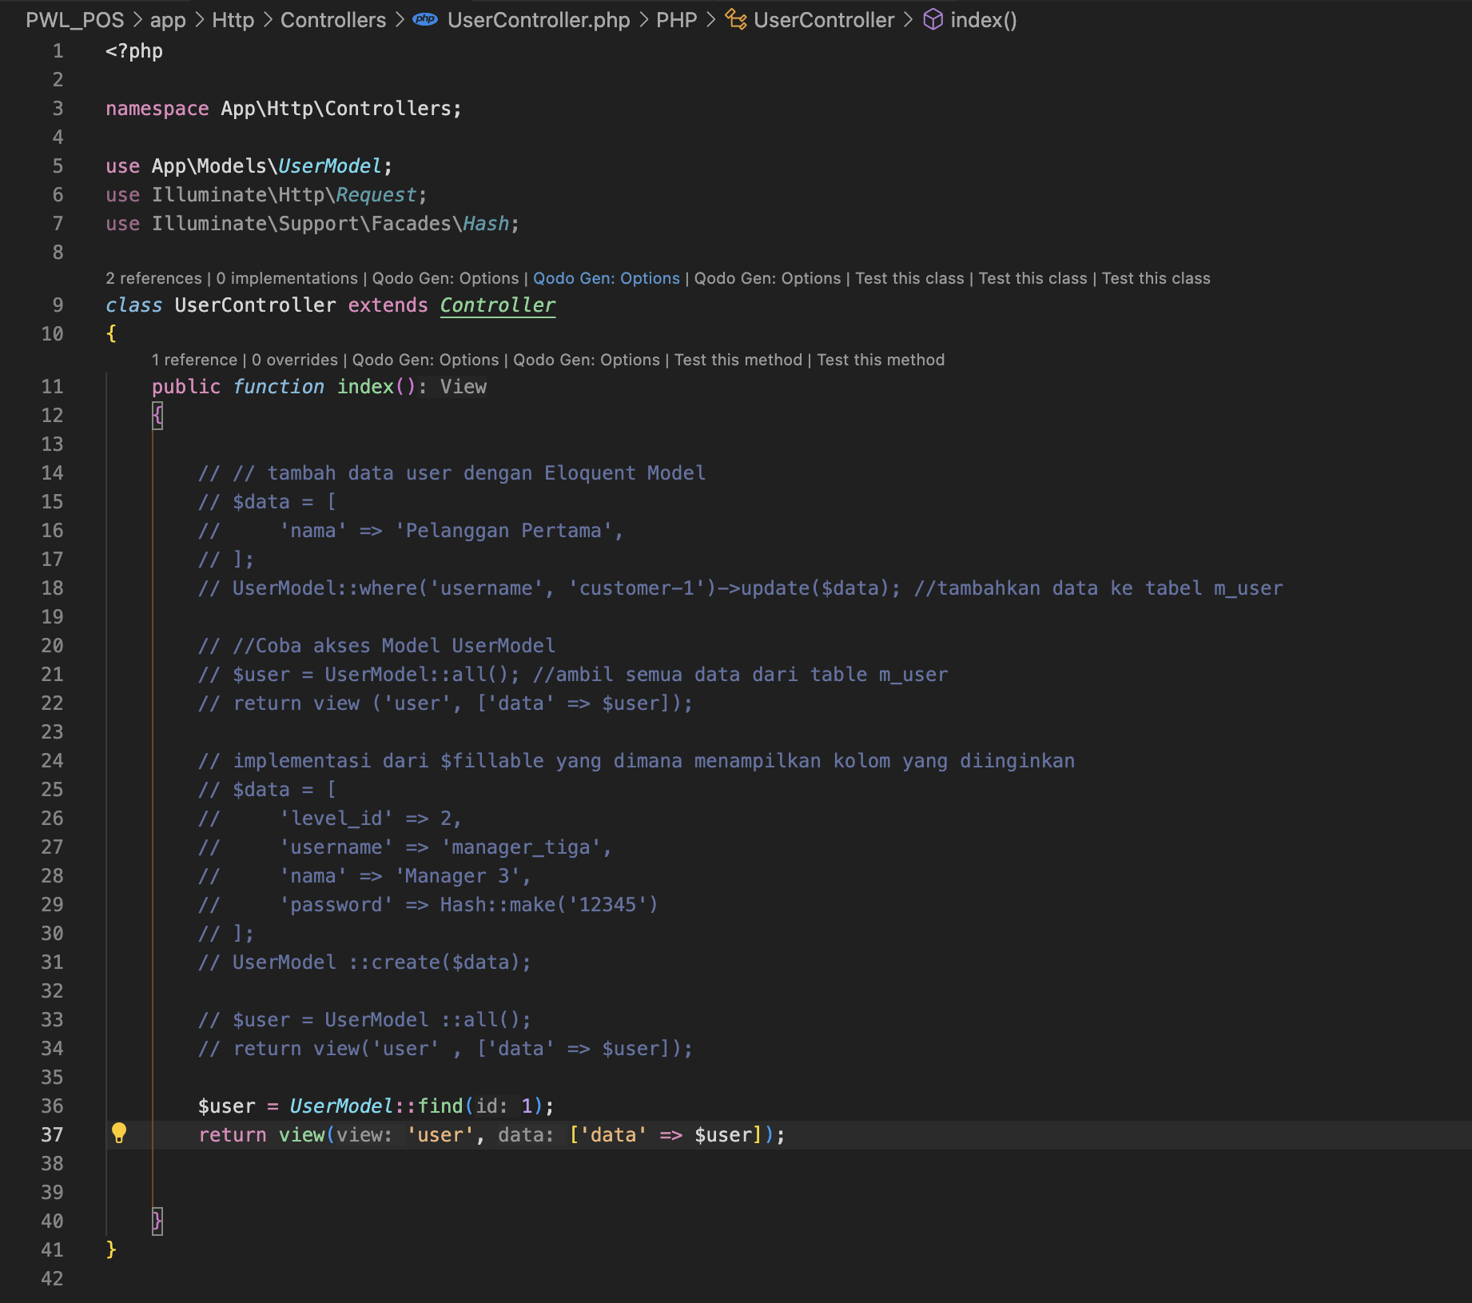**Steps 1 and 2 :**

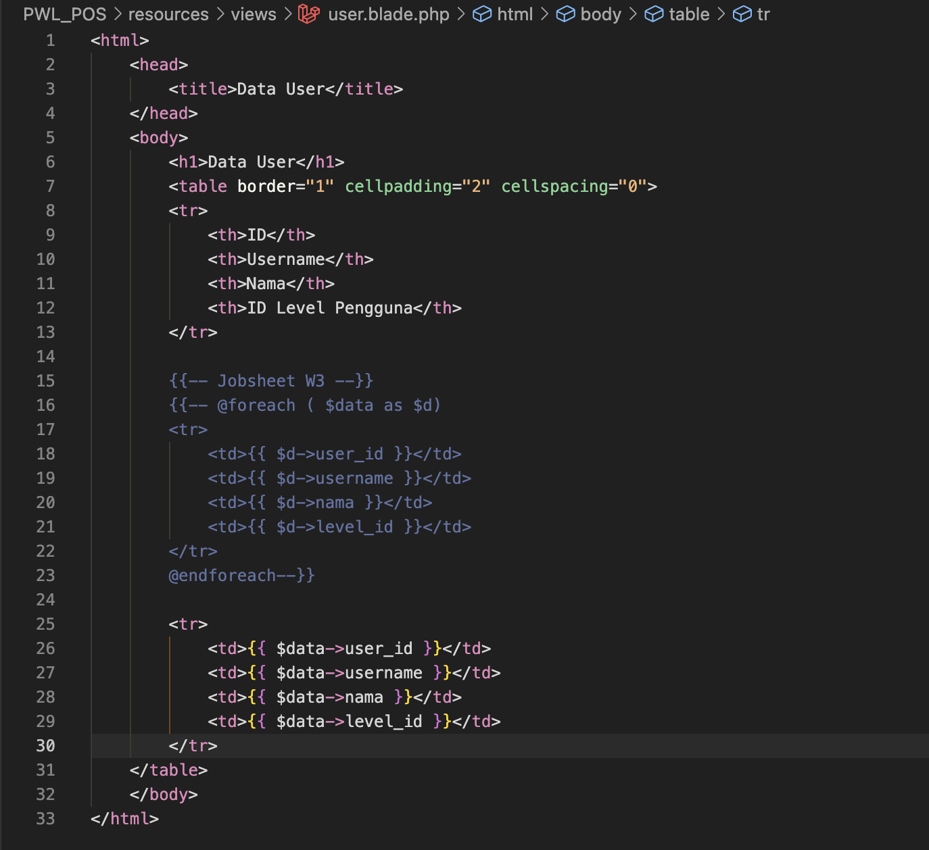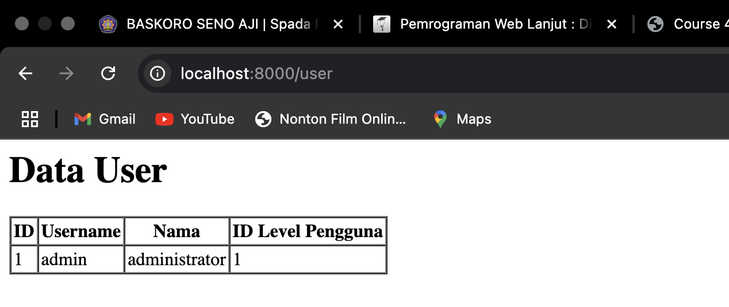

1. In this part we’re implementing the find function to retrieve the data that located in the user blade, in this terms we’ve already assigned the $user into the data where the data on the userblade already assigned to data
2. **Steps 4 Change the Controller :**

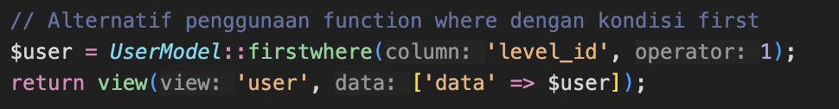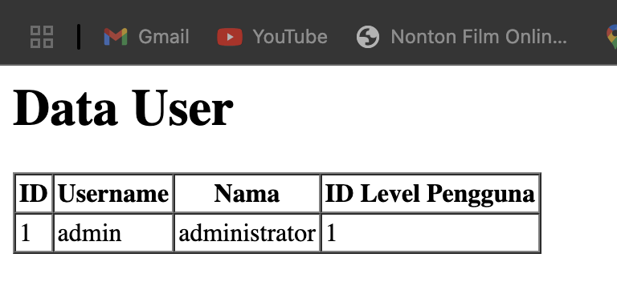

1. It retrieves a user record from the database using the firstWhere method, which searches for the first entry where the level_id column equals 1. The retrieved user data is then passed to a Blade view named user for rendering. The resulting webpage displays a table titled "Data User," showing user details such as ID, Username, Nama (name), and ID Level Pengguna (user level ID). In this case, the displayed user is an administrator with ID: 1, Username: admin, and ID Level Pengguna: 1
2. **Steps 6 Change the Controller :**



1. It retrieves a user record from the database using the firstWhere method, which finds the first entry where the level_id column equals 1. The retrieved user data is then passed to a Blade view named user using the view() function. The displayed webpage presents a table titled "Data User," showing user details such as ID, Username, Nama (name), and ID Level Pengguna (user level ID). In this case, the table displays an administrator with ID: 1, Username: admin, and ID Level Pengguna: 1.
2. **Steps 8 Change the Controller :**

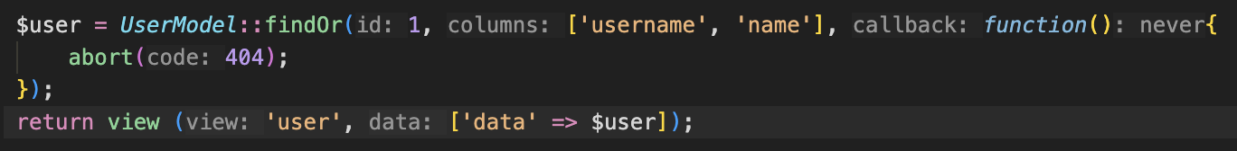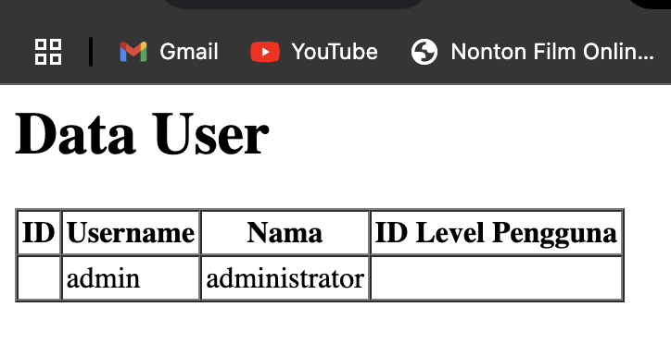

1. it retrieves a user record with ID = 1 using the findOr method, which searches for the user and selects only the username and name columns. If the user is not found, the callback function triggers an HTTP 404 error using abort(404), ensuring proper error handling. The retrieved user data is then passed to a Blade view named user and displayed in a table titled "Data User." The table presents the ID, Username, and Nama (name) but lacks the ID Level Pengguna column because it was not included in the query. The displayed user has Username: admin and Nama: administrator, confirming that the data retrieval and error handling mechanisms function correctly.
2. **Steps 10 Change the Controller :**

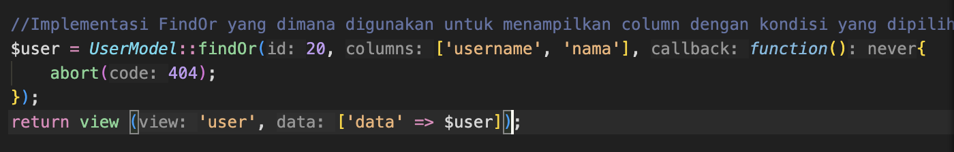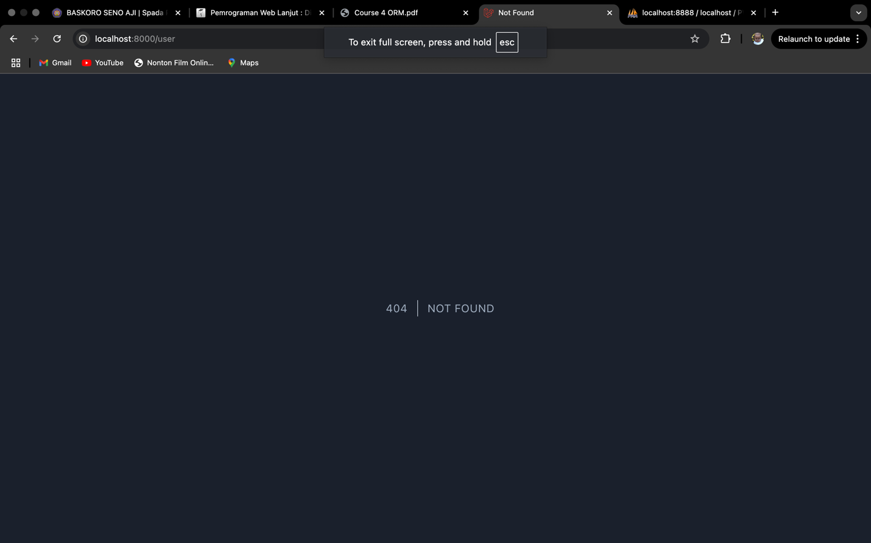

1. This demonstrates the use of the findOr method to retrieve a user record with ID = 20, selecting only the username and name columns. If no user with this ID is found, the callback function triggers an HTTP 404 error using abort(404), ensuring proper error handling. Since no record with ID = 20 exists in the database, the application returns a "404 | NOT FOUND" error page instead of rendering the user data. This implementation ensures that missing records are appropriately handled, preventing unexpected errors and improving the robustness of the system.

**Praktikum 2.2 Not Found Exceptions**

1. Save the Program Code Step 1 :

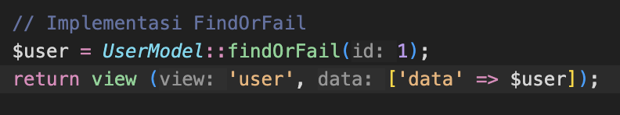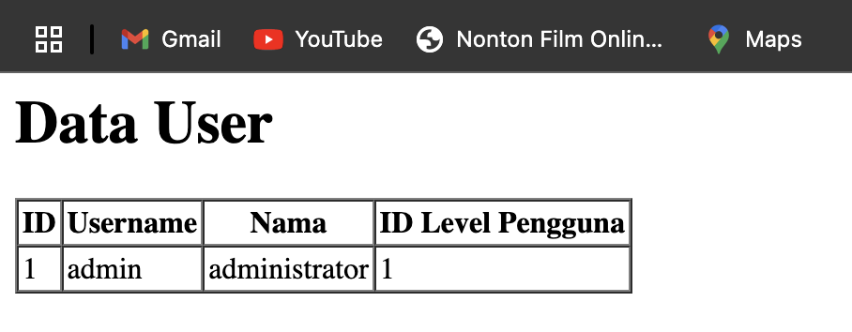

1. It demonstrates the use of the findOrFail method to retrieve a user record with ID = 1. Unlike findOr, which allows a fallback callback function, findOrFail will automatically throw a ModelNotFoundException if the specified record is not found. In this case, since a user with ID = 1 exists, the retrieved data includes the ID, username, name, and ID Level Pengguna fields. The data is then passed to the user view, which renders the information in a structured table format. This approach ensures that the application fails gracefully with an error if the requested record does not exist, maintaining data integrity and proper error handling.
2. Save the Program Code Step 3 :

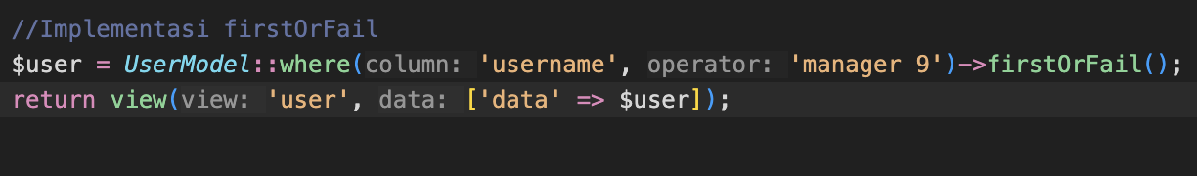

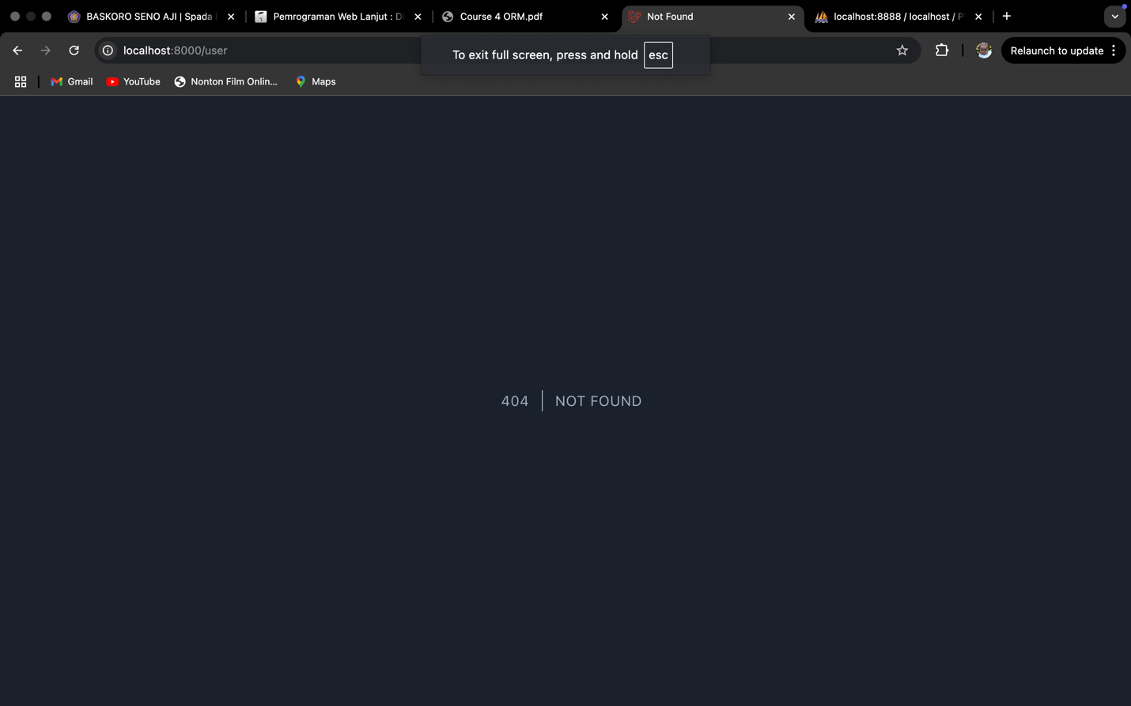

1. It demonstrates the use of Laravel’s firstOrFail() method to retrieve a user based on a specific condition. If a user with the username 'manager 9' exists in the database, the query successfully fetches the record and passes it to the view. However, if no matching user is found, firstOrFail() triggers a ModelNotFoundException, which results in a 404 | NOT FOUND error page. This method is useful when ensuring that a record must exist, preventing the application from proceeding with null values and enforcing data integrity.

**Praktikum 2.3 Retrieving Aggregrates**

1. **Program Code Step 1 :**

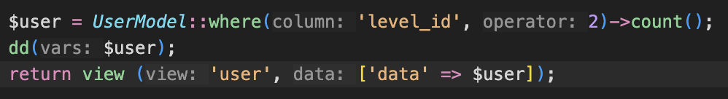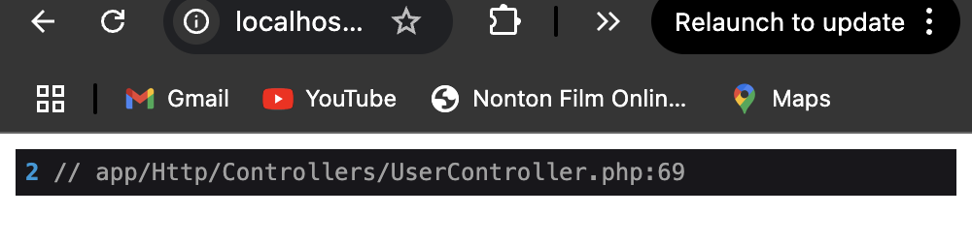

1. It demonstrates the use of Laravel’s count() method in conjunction with the where() query to determine the number of users with a specific level_id of 2. The result is stored in the $user variable, which is then displayed using Laravel’s debugging function dd($user). This function dumps the value and stops further execution, allowing developers to inspect the retrieved count before passing it to the view. The output in the browser shows 2, indicating that two users meet the specified condition. This method is useful for quickly obtaining aggregate data without retrieving entire records.
2. 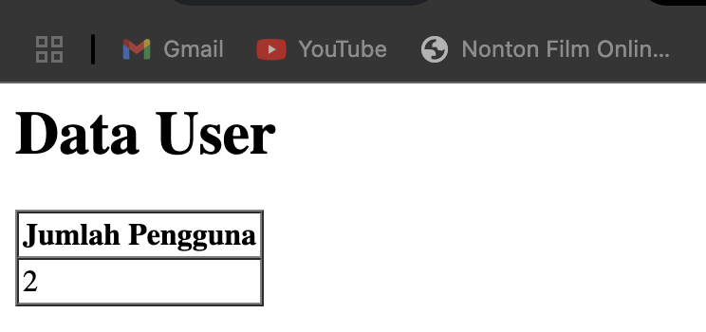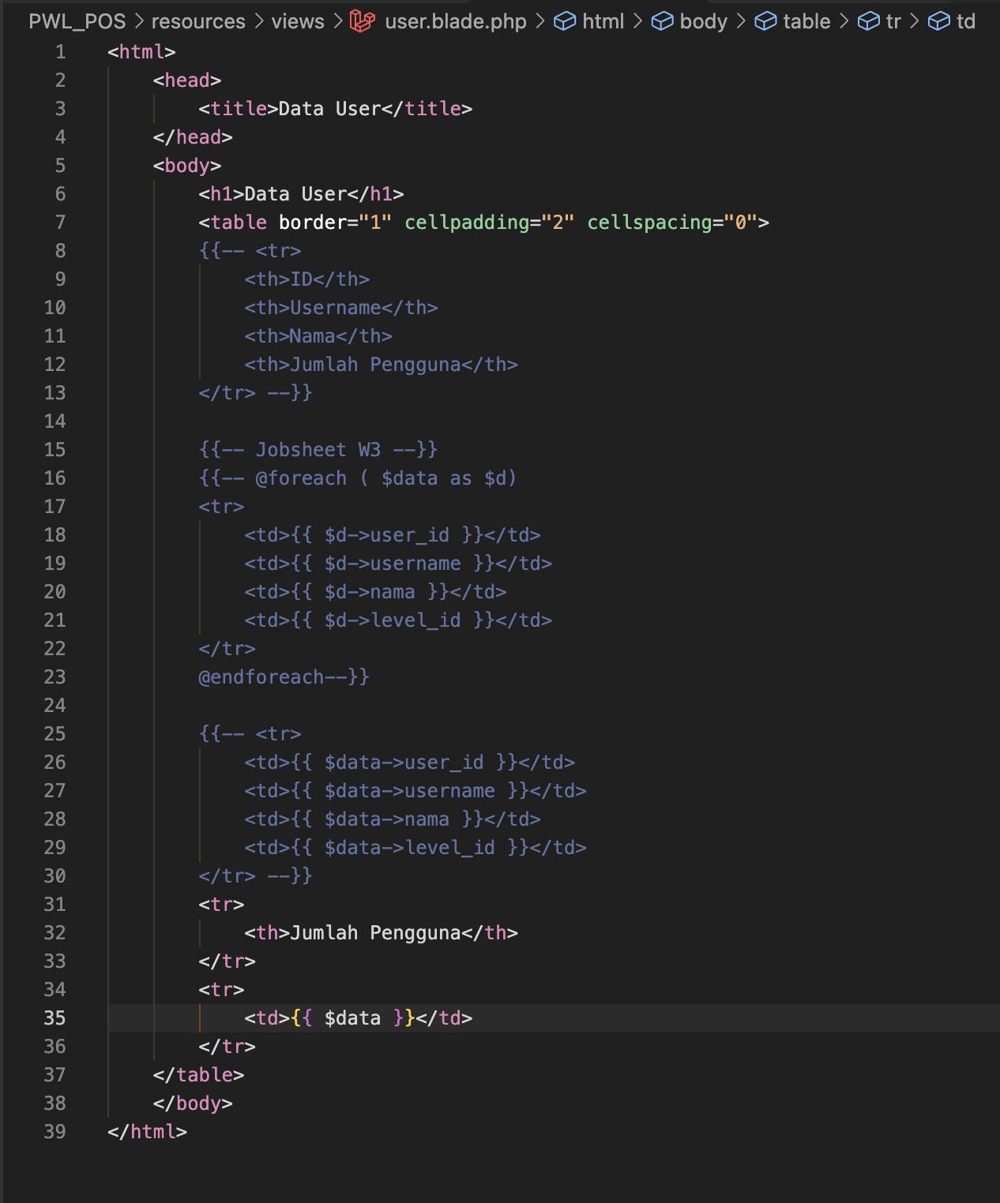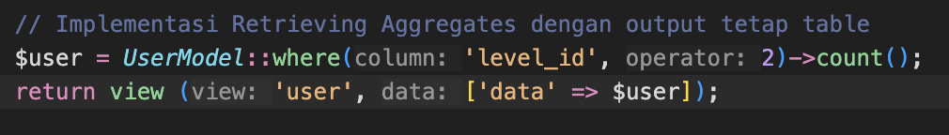**The number script of step 1 :**
3. The data in an HTML table while incorporating an aggregate function to count users with a specific level_id. The controller retrieves the count using UserModel::where('level_id', 2)->count();, then passes it to the view. The Blade template originally included a commented-out section for displaying multiple user records, but it now solely displays the total count of users under the "Jumlah Pengguna" (User Count) row. The rendered output correctly displays the count (2) in the table format, demonstrating how aggregate data can be integrated while maintaining the HTML table structure.

**Praktikum 2.4 Retrieving or Creating Models**

1. 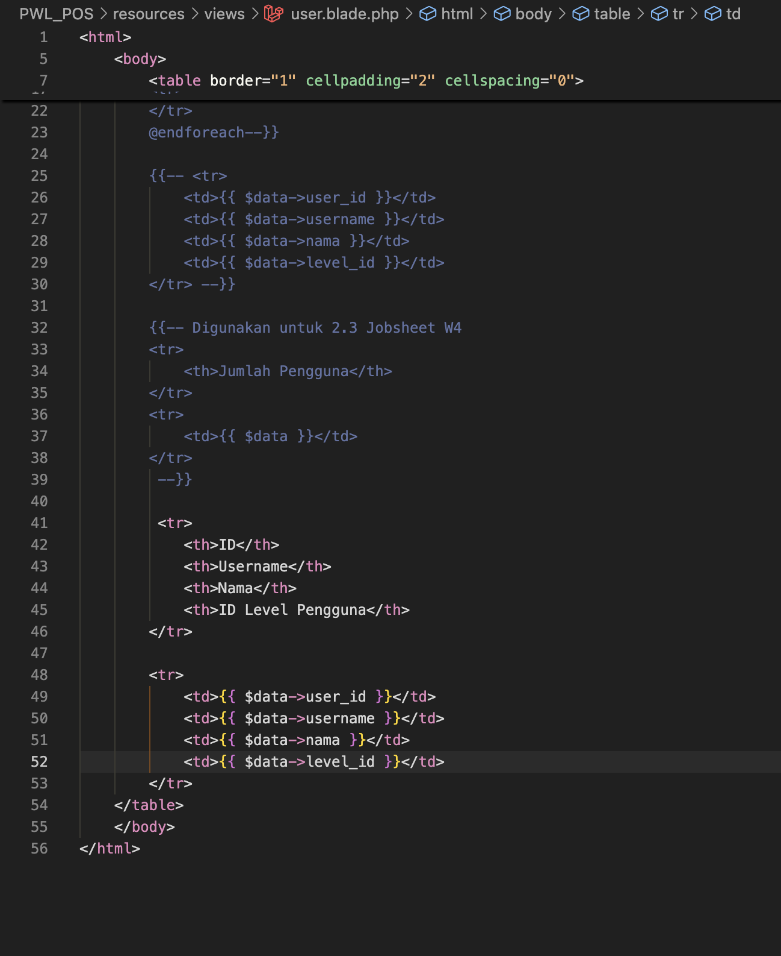**The Program Code from Step 1 and 2** 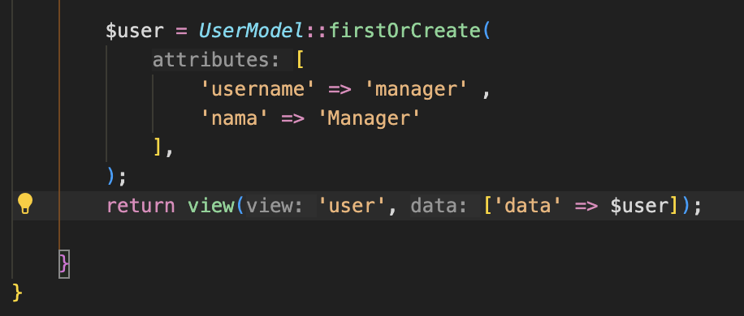

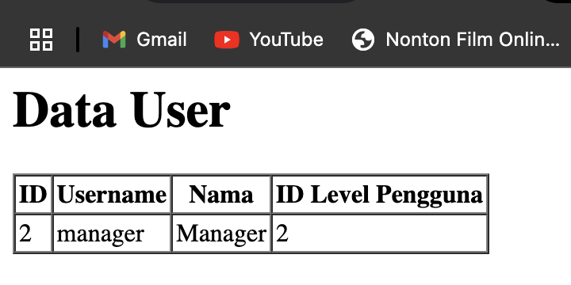

1. The user data is displayed in a structured table format. The user.blade.php file retrieves data from the controller and dynamically presents it in the view. The table consists of four columns: ID, Username, Nama (Name), and ID Level Pengguna (User Level ID). The variable $data contains user information, which is displayed within <td> elements. The rendered output correctly displays a single user's details—ID: 2, Username: manager, Name: Manager, and Level ID: 2. However, the implementation lacks a loop (@foreach) to handle multiple users, meaning only a single user’s data will be shown
2. **Program Code Step 4 :**

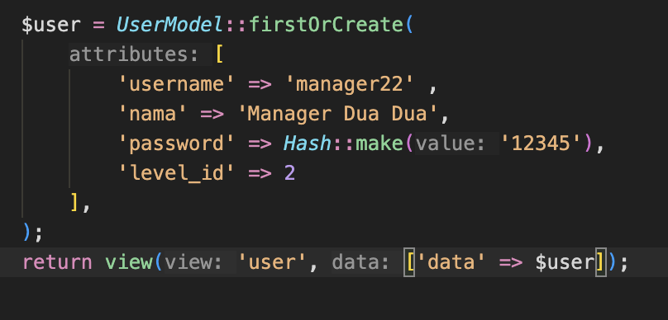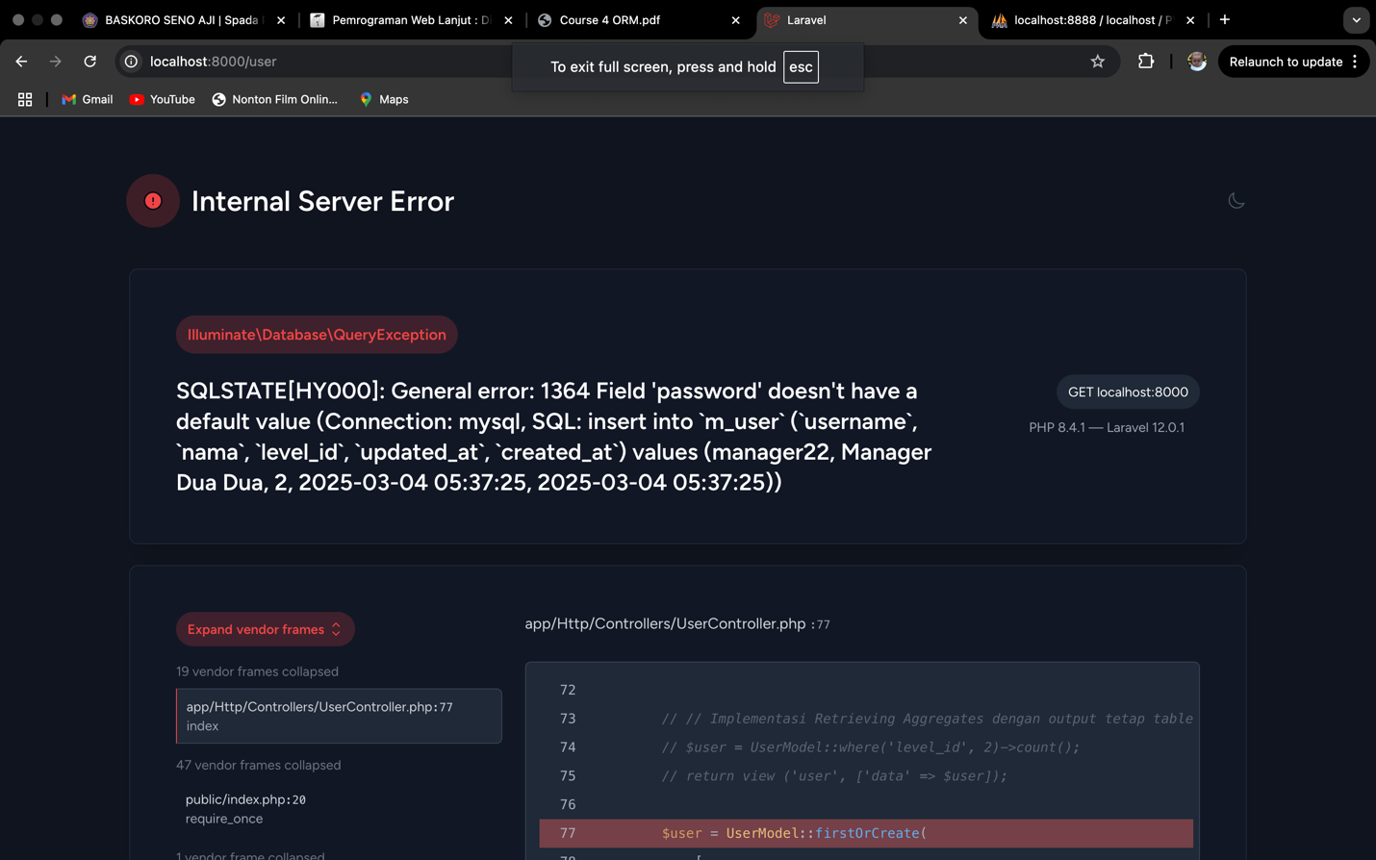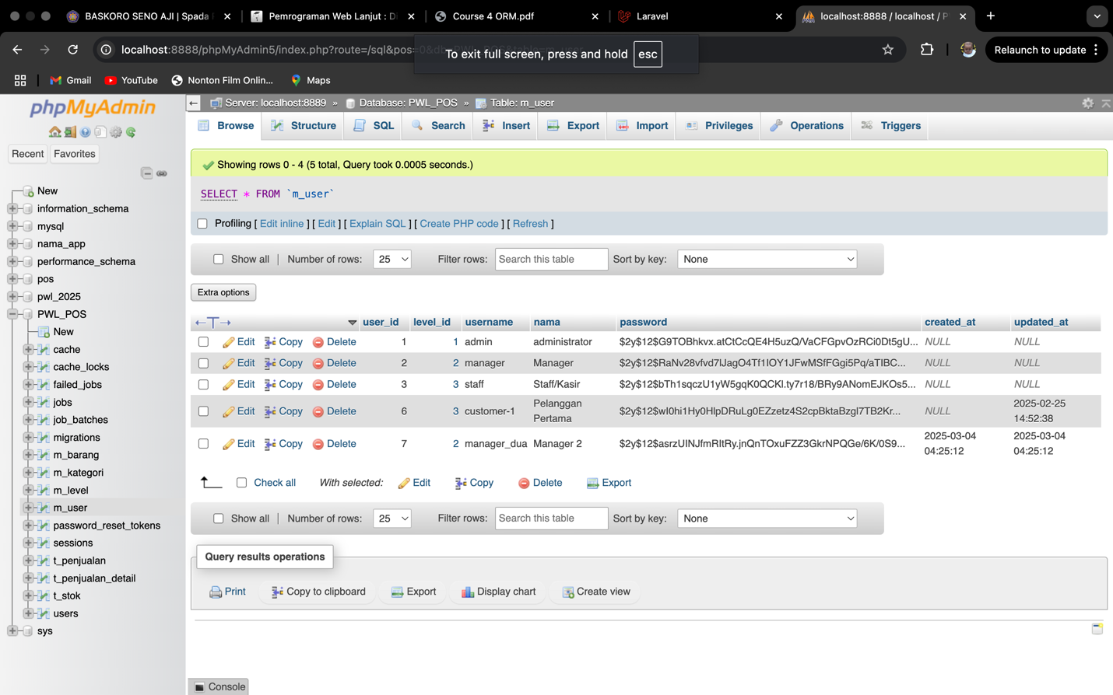

1. The code snippet attempting to create a user record using UserModel::firstOrCreate(), alongside a database error message and a phpMyAdmin table structure. The error message, "SQLSTATE[HY000]: General error: 1364 Field 'password' doesn't have a default value," indicates that the password field in the m_user table is defined as NOT NULL without a default value, causing an issue when inserting a new record. Although the code correctly hashes the password using Hash::make('12345'), the record insertion fails, likely due to Laravel’s mass assignment protection or an issue with the model’s $fillable properties. The phpMyAdmin screenshot shows existing users, confirming that the table enforces a strict requirement for the password field. To resolve this, the developer should ensure the password field is included in the $fillable array within UserModel.php, manually update the password field after user creation, or modify the database schema to allow a default value for the password column.
2. The Program Code Step 6

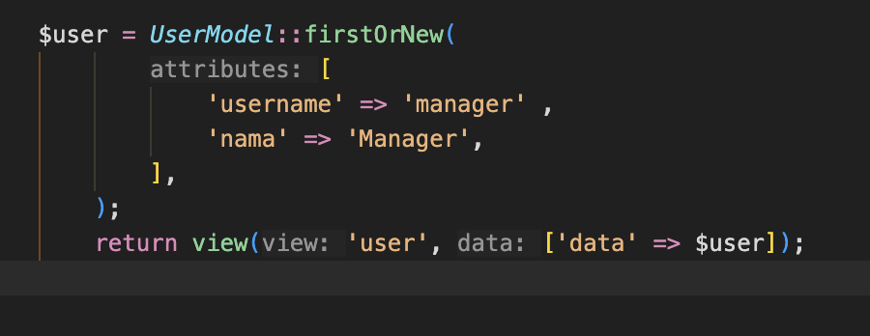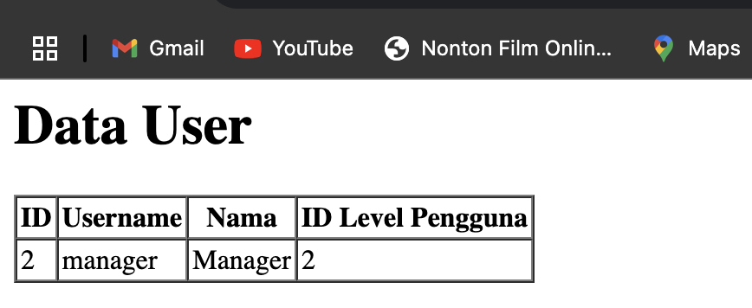

1. The code snippet using UserModel::firstOrNew() and the corresponding output displaying user data in an HTML table. The firstOrNew() method attempts to find a user with the given attributes (username = 'manager' and nama = 'Manager'). If the record exists, it retrieves it; if not, it creates a new instance but does not persist it to the database unless explicitly saved using $user->save(). The HTML table below confirms that a user with ID = 2, username = 'manager', nama = 'Manager', and ID Level Pengguna = 2 is displayed, suggesting that this record was already present in the database. However, if this user was newly created by firstOrNew(), it would not be saved unless followed by $user->save(). To ensure data persistence, using firstOrCreate() or explicitly calling $user->save() after firstOrNew() is recommended.
2. The Program Code Step 8

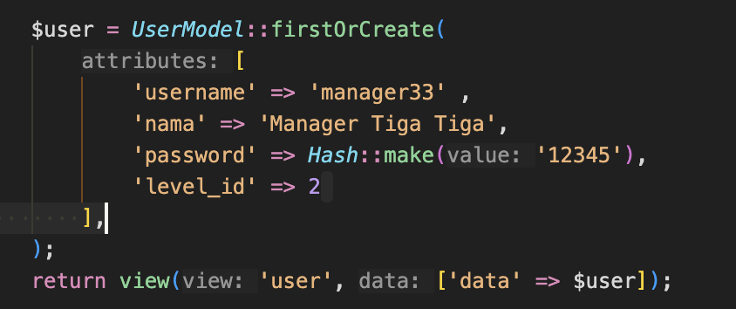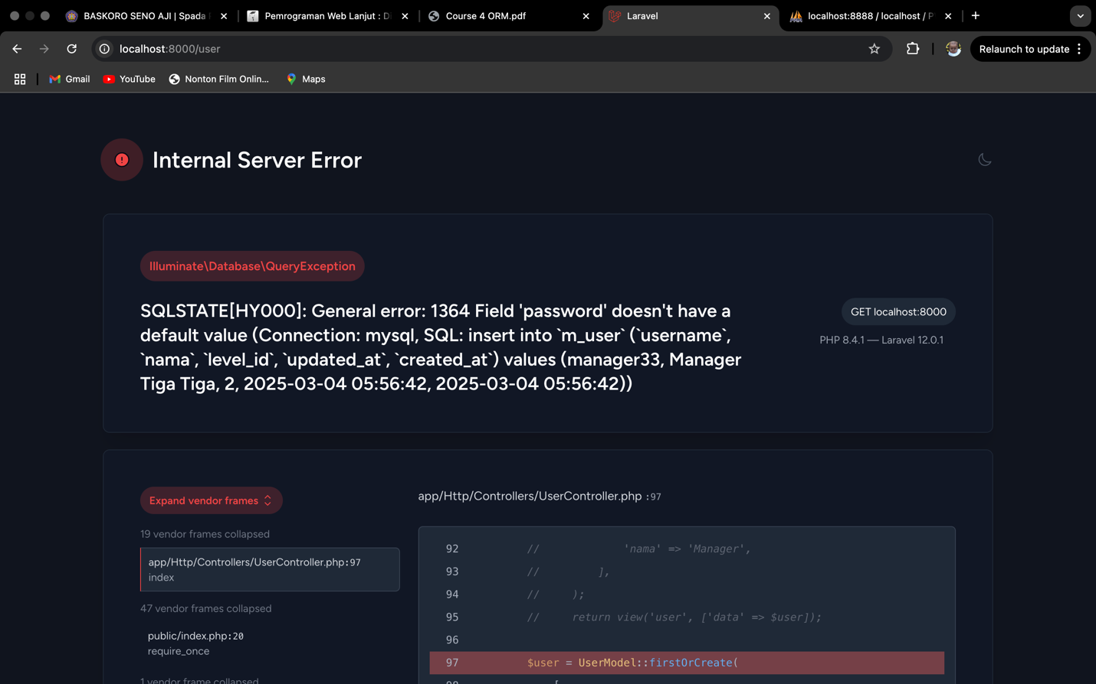

1. The code snippet using UserModel::firstOrCreate() to either find or insert a user with attributes including a username, name, hashed password, and level ID. The second part of the image shows an internal server error in the browser, specifically an Illuminate\Database\QueryException indicating an SQL error (SQLSTATE[HY000]: General error: 1364), which states that the password field does not have a default value. The error occurs when attempting to insert data into the m_user table, suggesting that the password field is either not being properly assigned or is required but missing during the database operation. The Laravel debug screen highlights the problematic line within the UserController.php file, pointing to the firstOrCreate() function call as the source of the issue.

**Praktikum 2.5 Attribute Changes :**

1. Save the Program Code Step 1 : 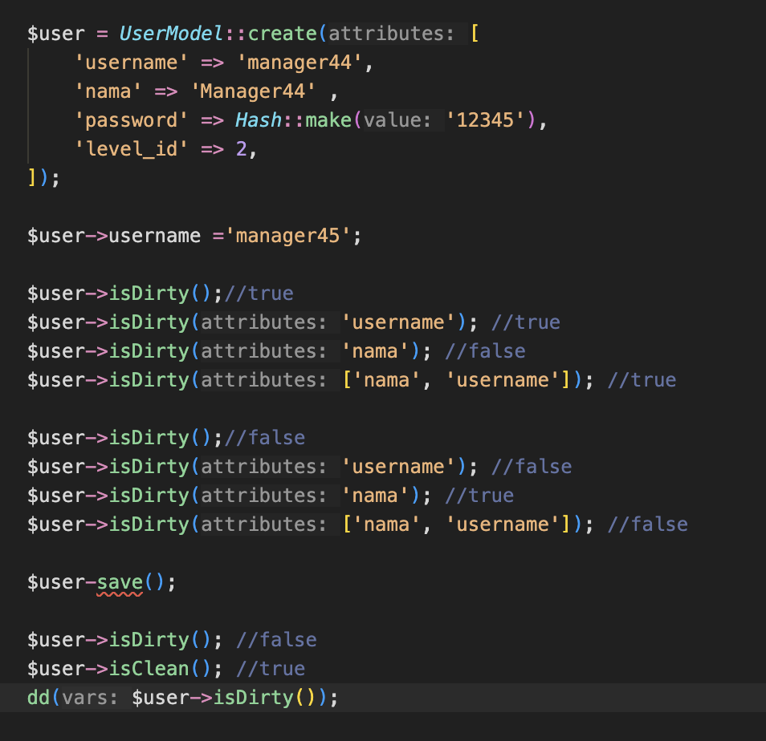

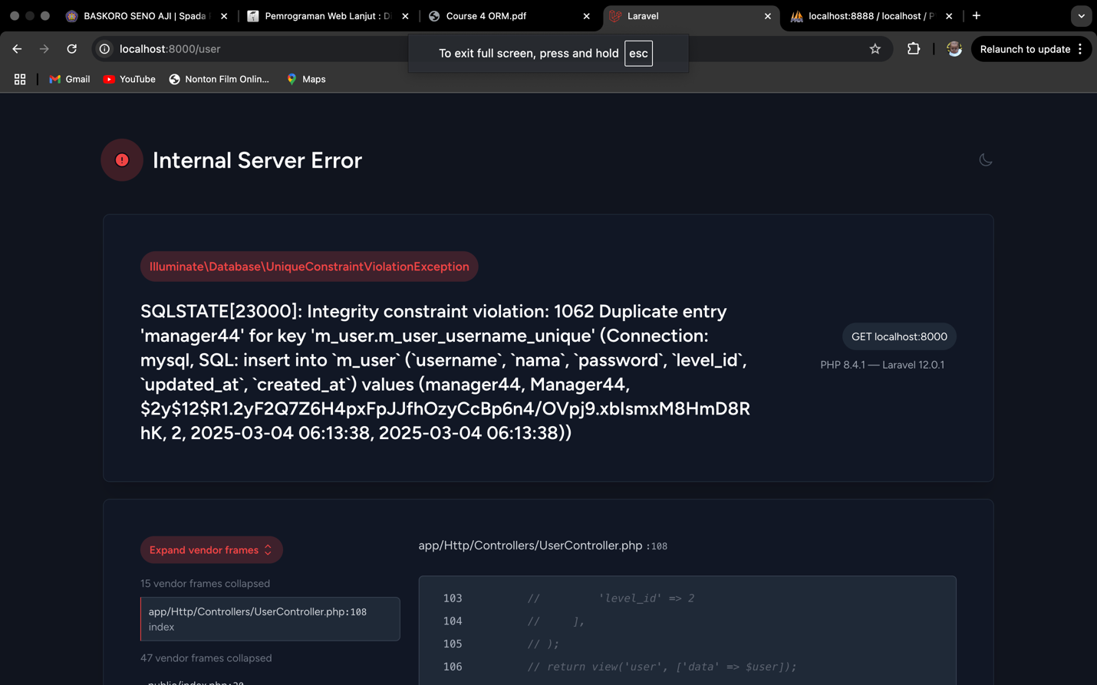

1. The Eloquent code snippet and an error message from a failed database operation. The code demonstrates creating a UserModel instance with attributes like username, nama, password, and level_id, then modifying the username field and checking its state using the isDirty() method. The isDirty() function is used before and after saving the model to detect unsaved changes, while isClean() confirms whether the model is unchanged after saving. The second part of the image displays an Illuminate\Database\QueryException due to a SQLSTATE[23000] Integrity constraint violation: 1062 Duplicate entry 'manager44' for key 'm_user.m_user_username_unique', indicating an attempt to insert a username that already exists in the database.
2. Save the Program Code Step 3 :

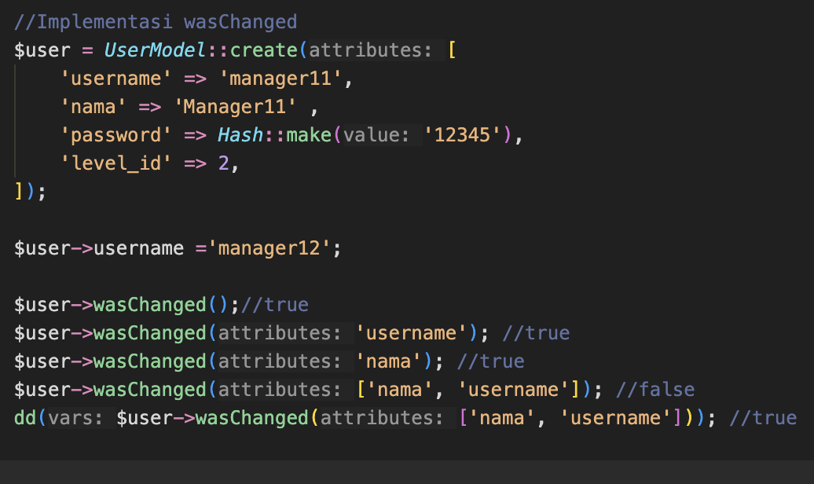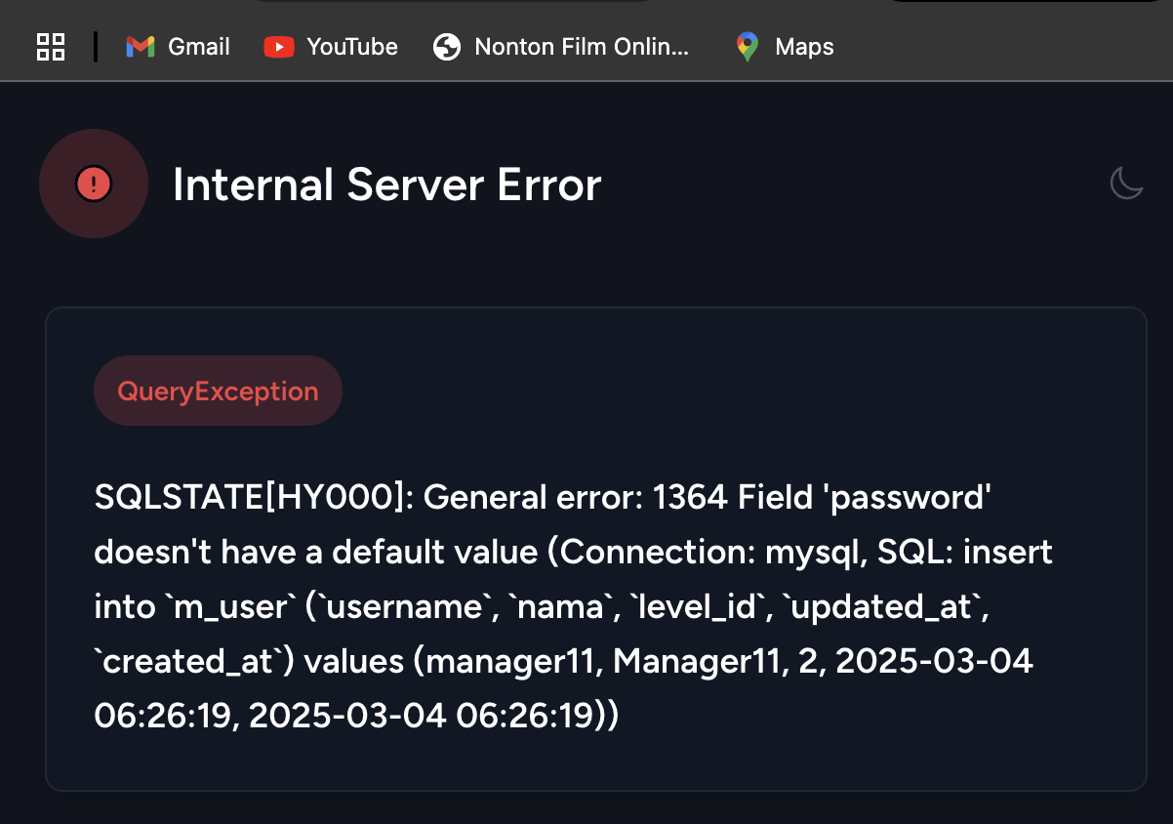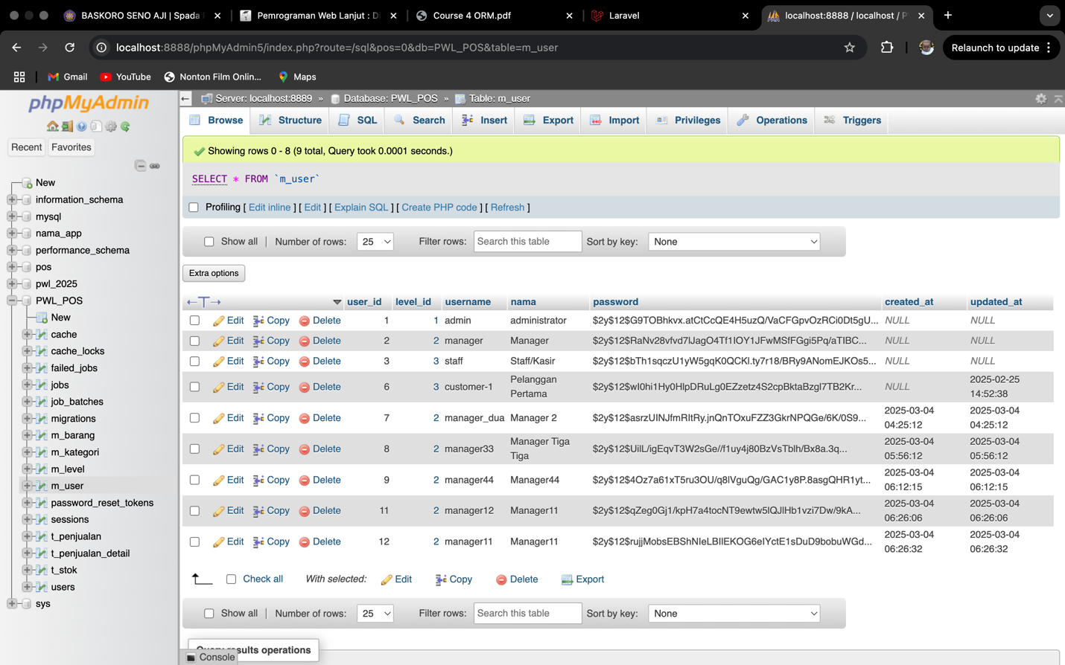

1. An encountering an Internal Server Error due to an SQL issue. The error message indicates a SQLSTATE[HY000]: General error: 1364 Field 'password' doesn't have a default value, meaning the password field is required but was not included in the INSERT statement when creating a new user in the m_user table. The Laravel code snippet uses the wasChanged() method to check for modifications in model attributes after updating the username, but the issue arises earlier when attempting to store the user data. The SQL error message highlights that the password column was omitted, likely because it's not being set correctly in the model or database schema. The phpMyAdmin screenshot displays existing user records in the m_user table, confirming that other users have hashed passwords stored, but new insertions fail due to the missing password value.

**Praktikum 2.6 Create, Read, Update, Delete :**

* Code From Steps 1 and 2

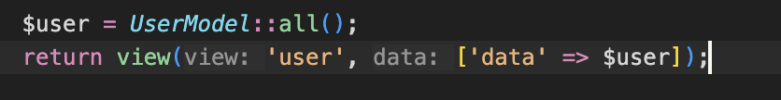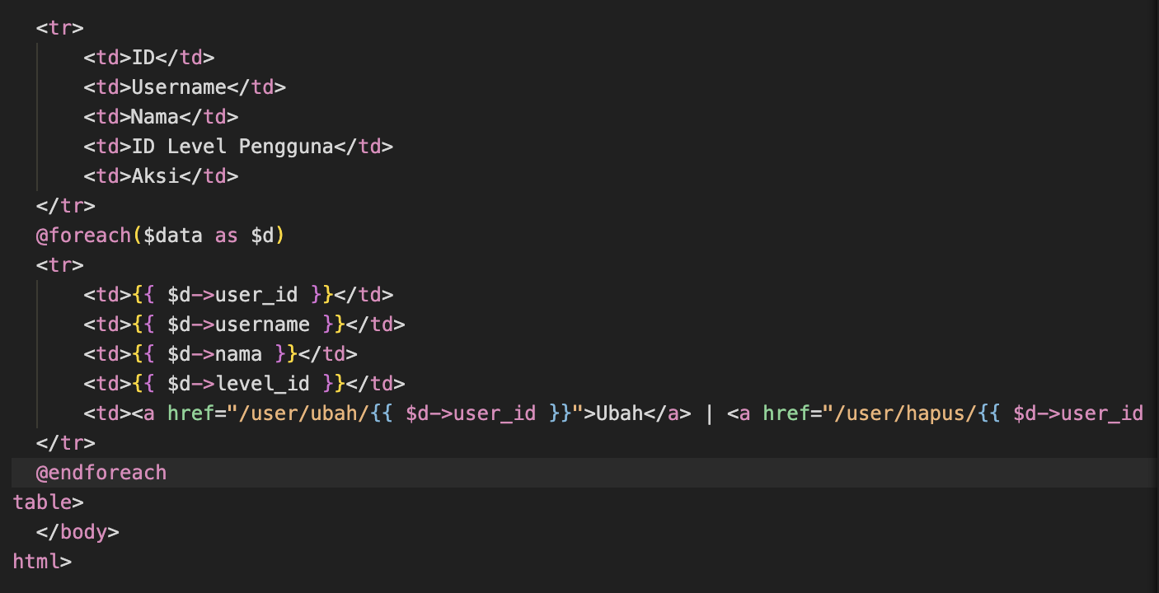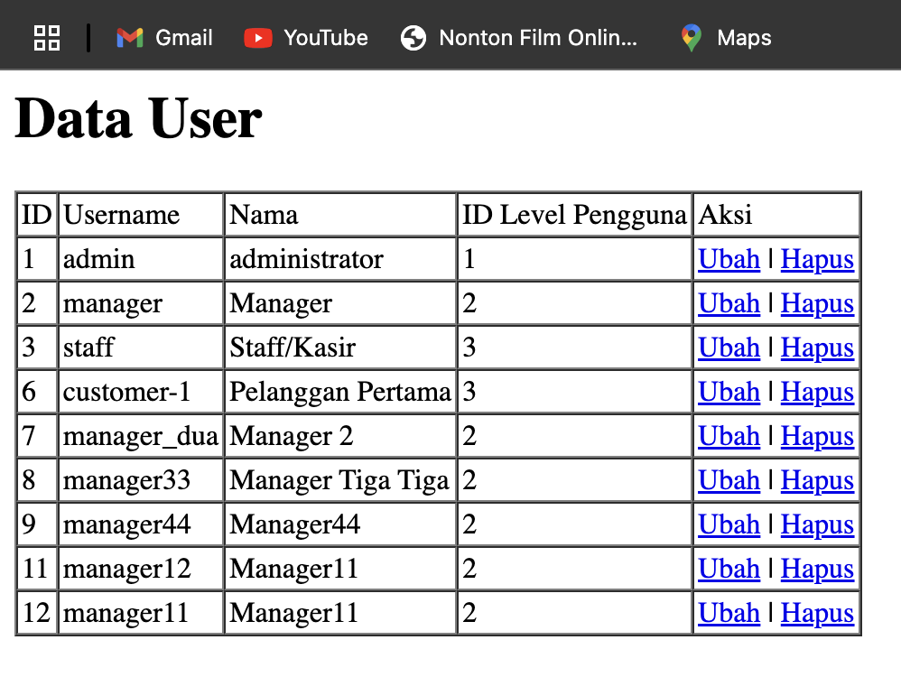

* **Explanations** : The controller retrieves all user records from the UserModel using UserModel::all() and then passes this data to the Blade view named 'user' with the variable $data. Within User.blade.php, the view iterates over $data using the @foreach($data as $d) directive, displaying each user's details—including ID, username, name, and level ID—in separate <td> elements. Additionally, two action links, "Ubah" (Edit) and "Hapus" (Delete), are included in each row, referencing the respective user IDs to facilitate editing and deletion operations.
* 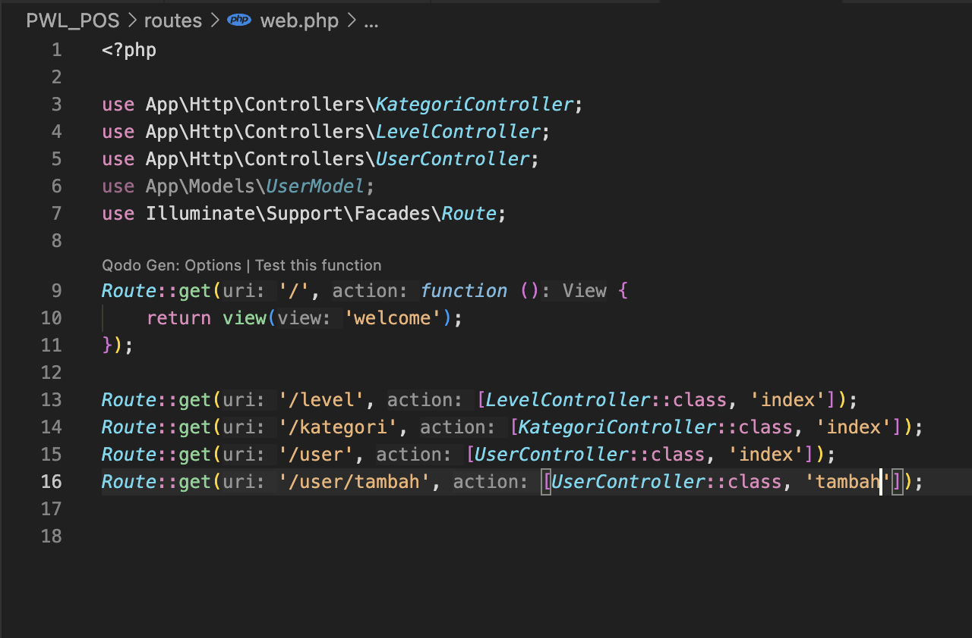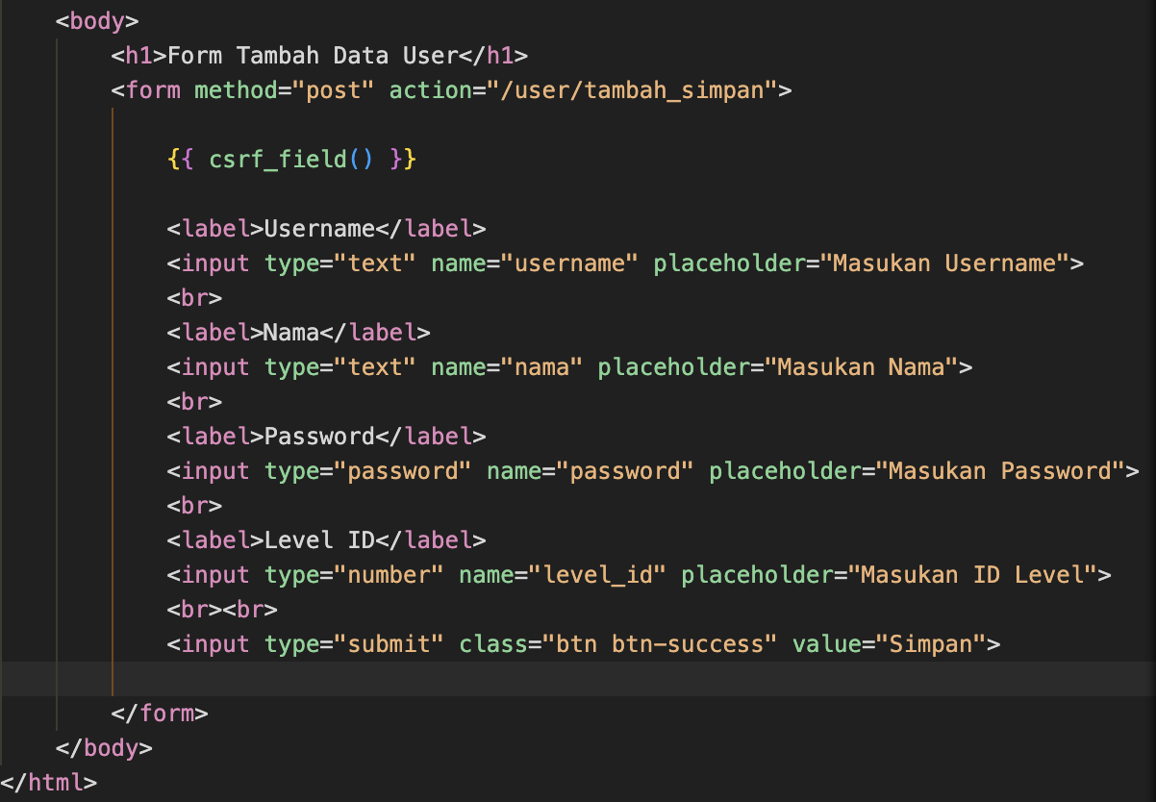Step 4 and 6 :

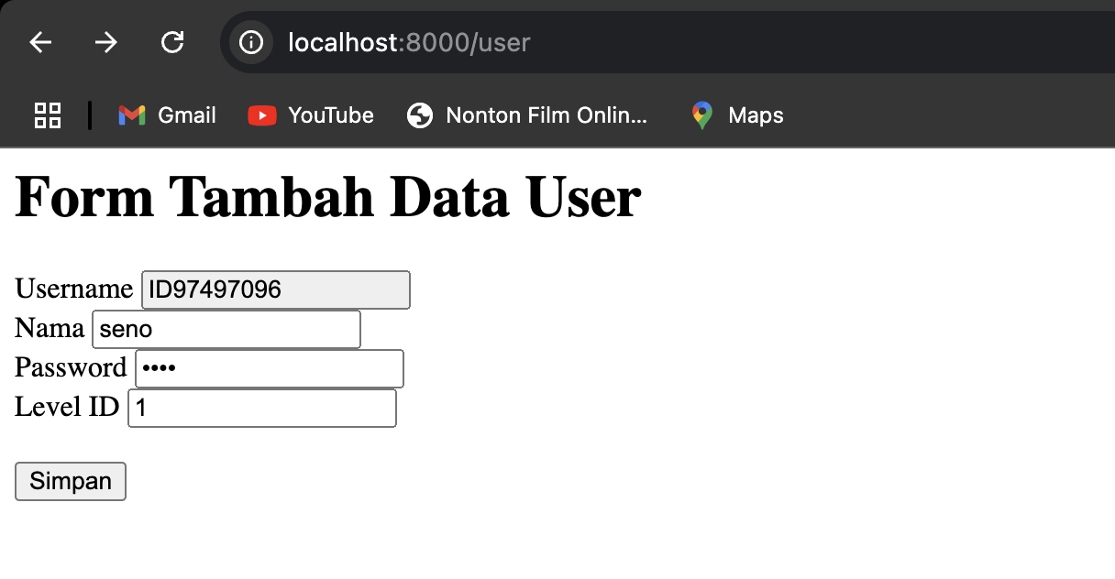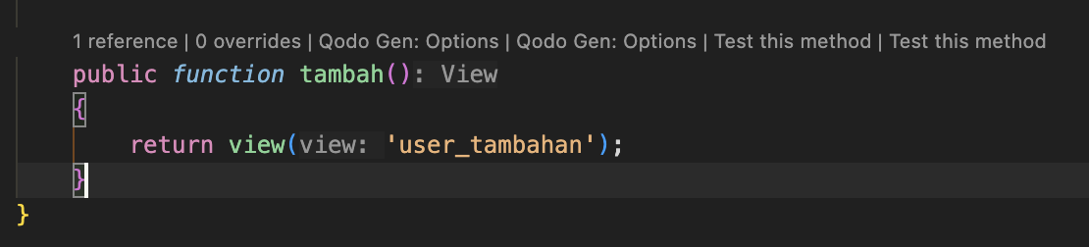

* **Explanations :** The user_tambah.blade.php view contains a form that utilizes the POST method to submit user data to the '/user/tambah_simpan' route. For security, it includes a CSRF token (@csrf) and provides input fields for username, nama, password, and level_id, along with a submit button labeled "Simpan" (Save).

The route Route::get('/user/tambah', [UserController::class, 'tambah']); handles GET requests to '/user/tambah', invoking the tambah method in UserController. This method returns the user_tambah Blade view, ensuring the form is displayed when users navigate to '/user/tambah'.

* Step 8-13 :

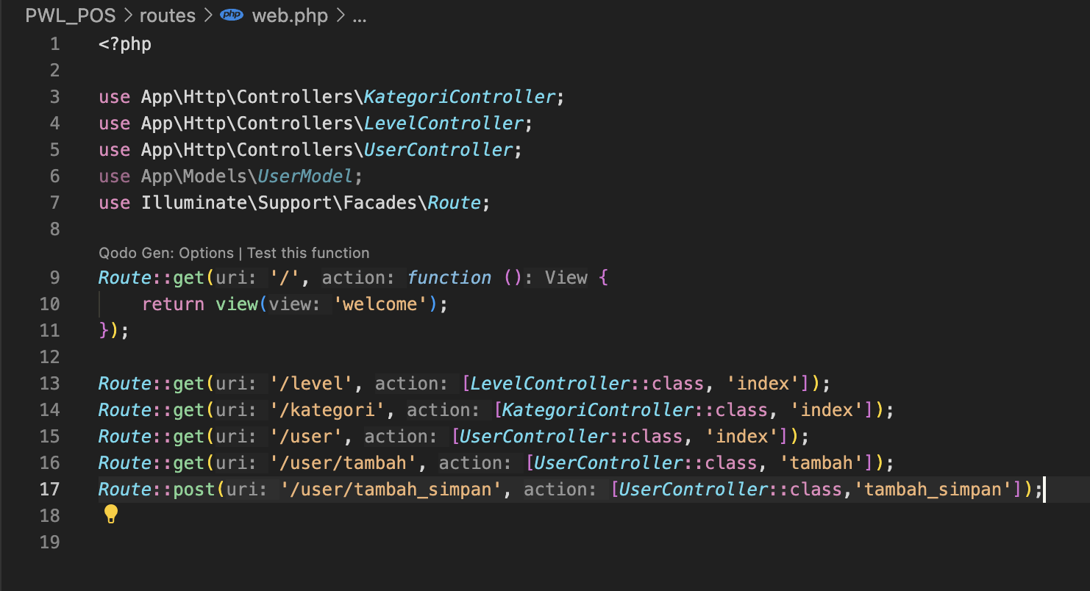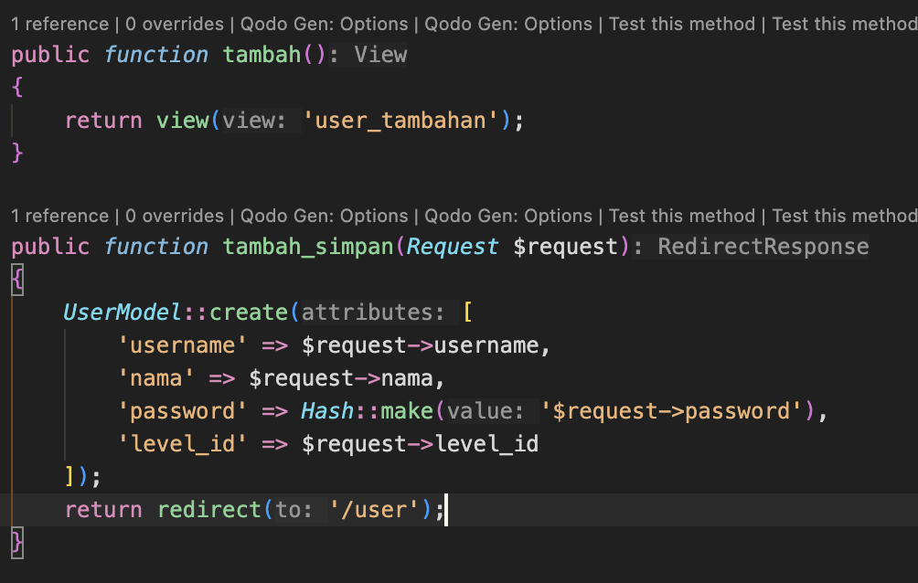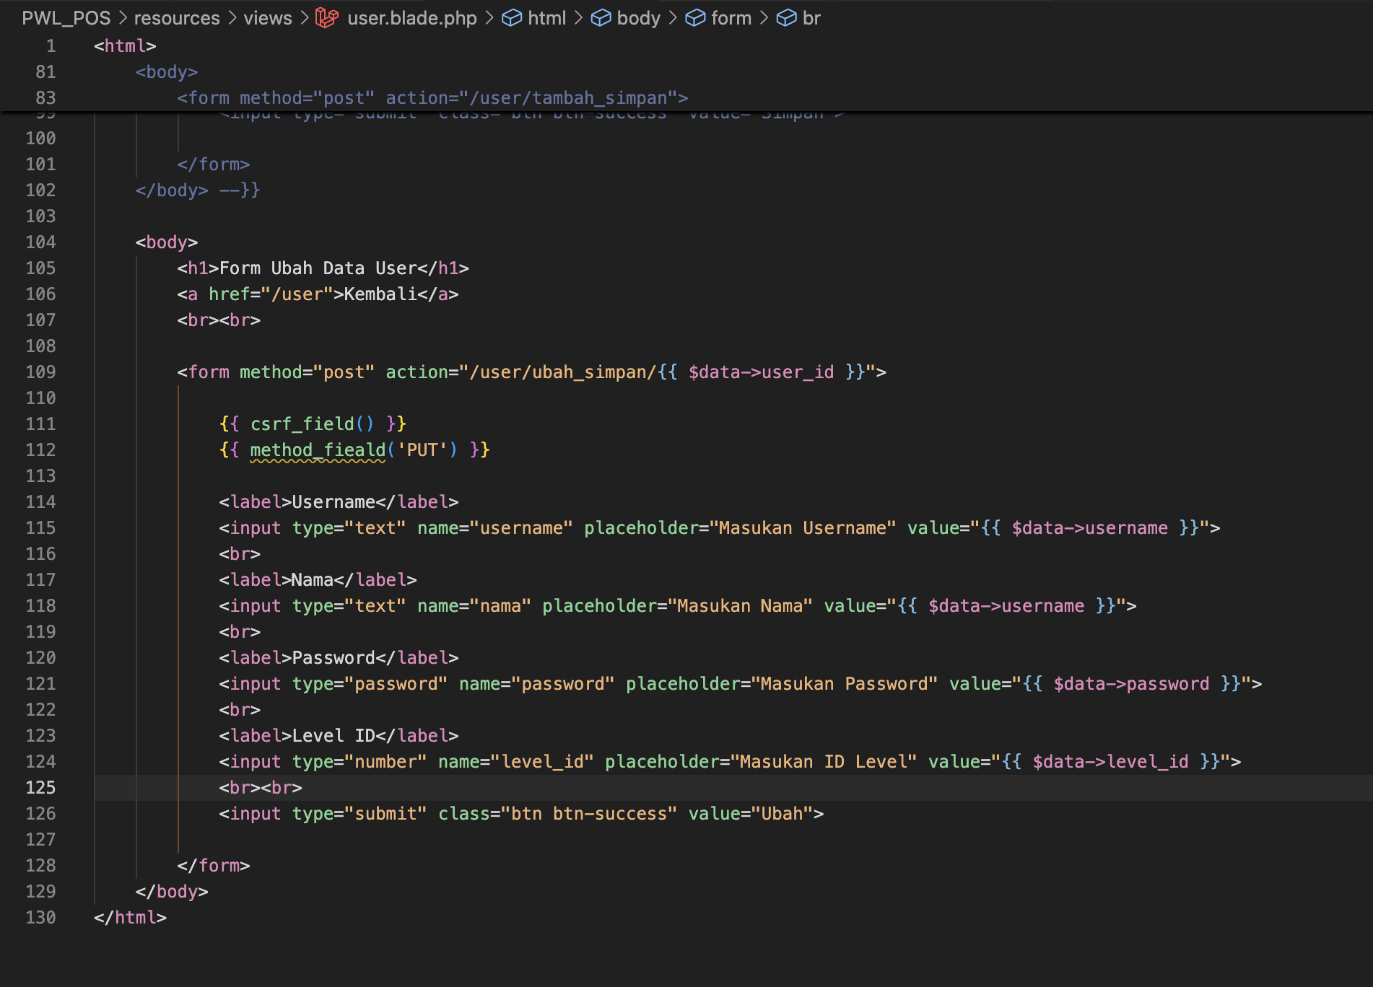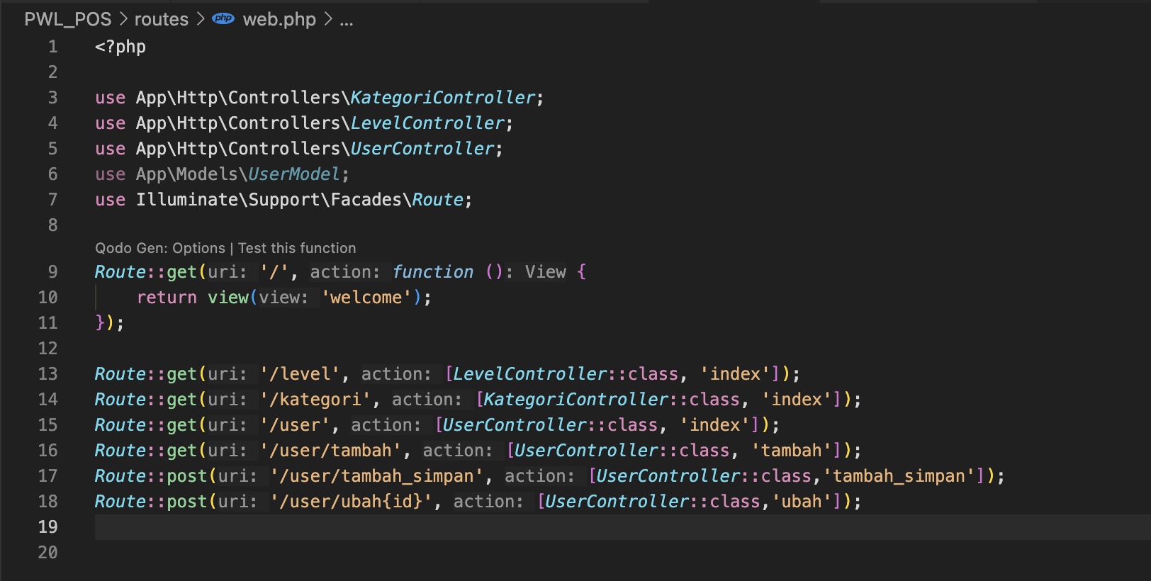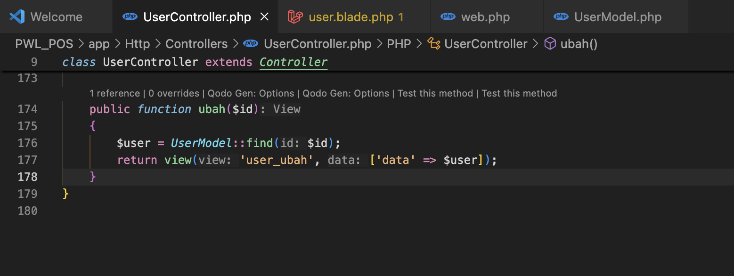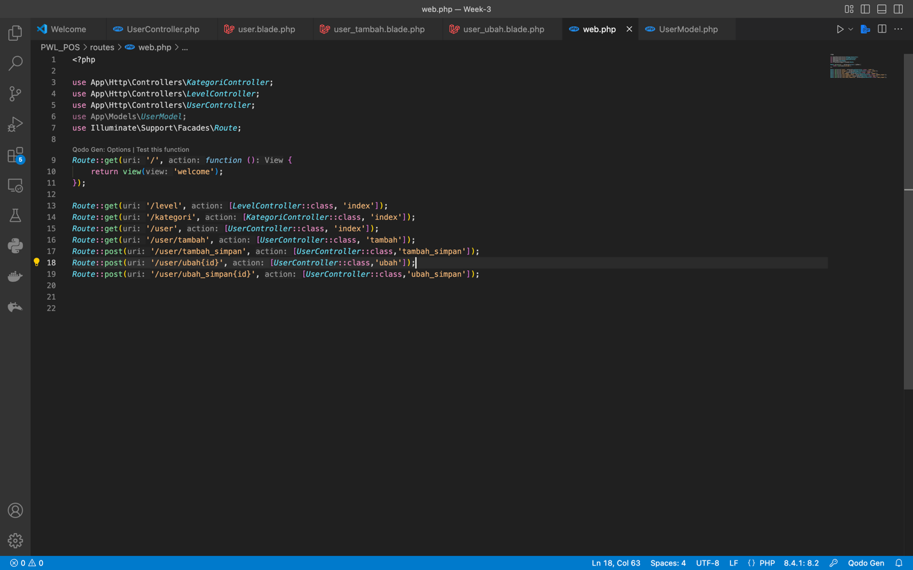****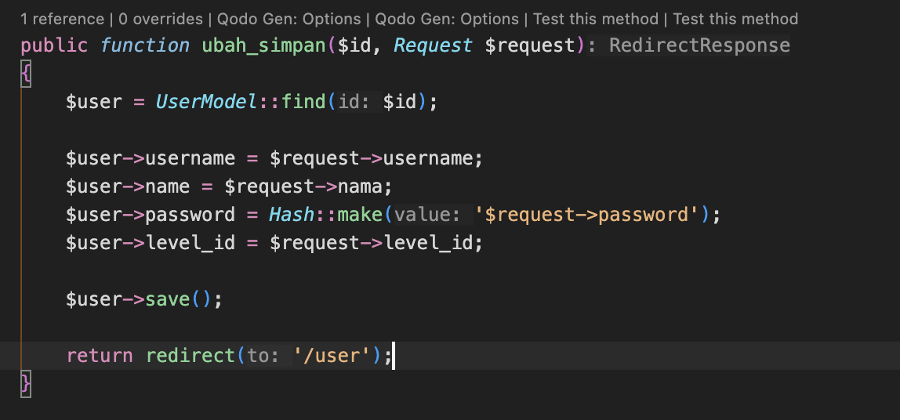

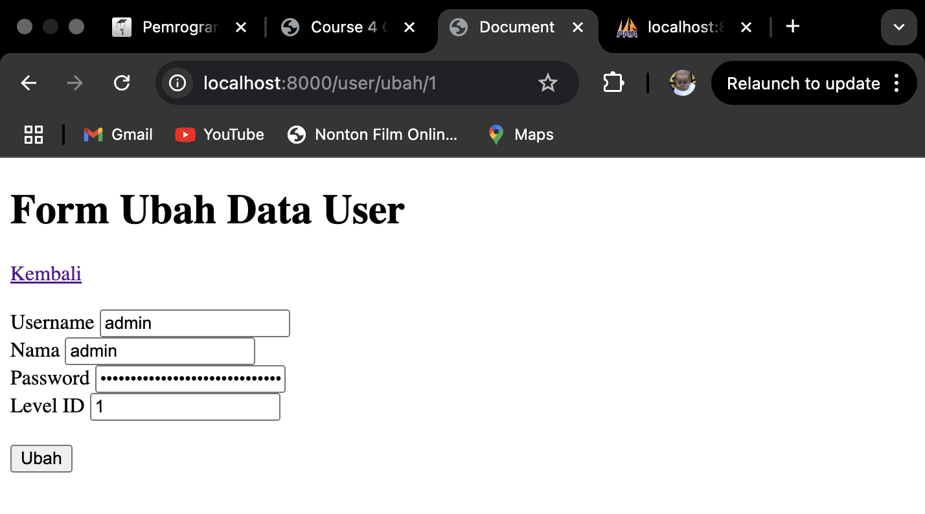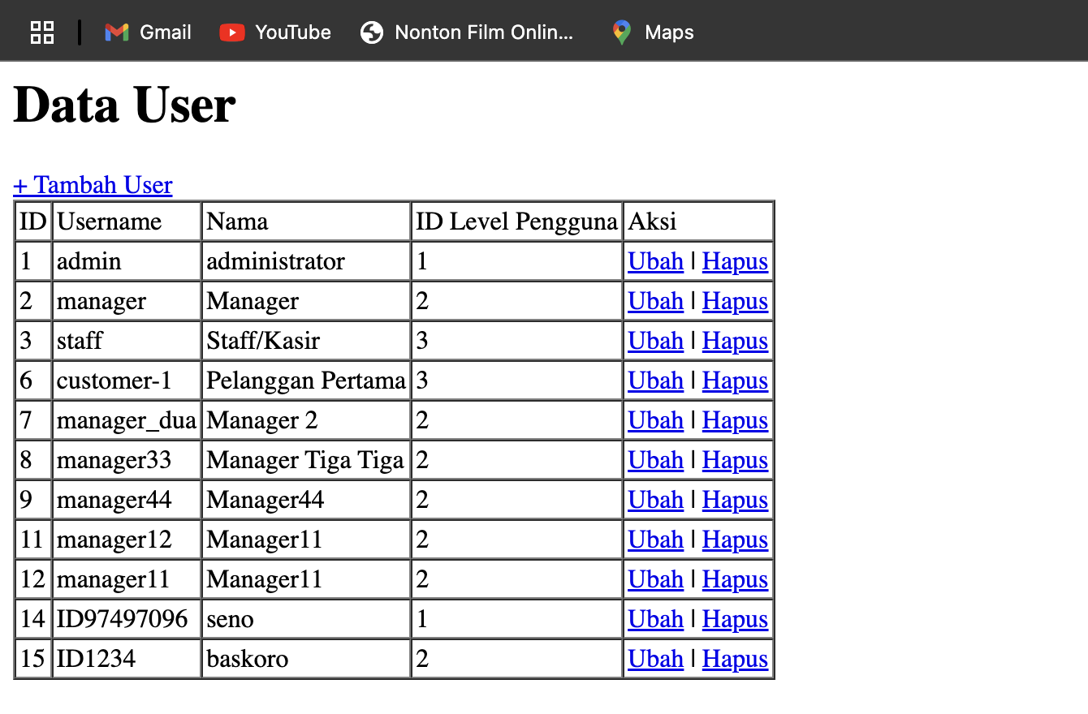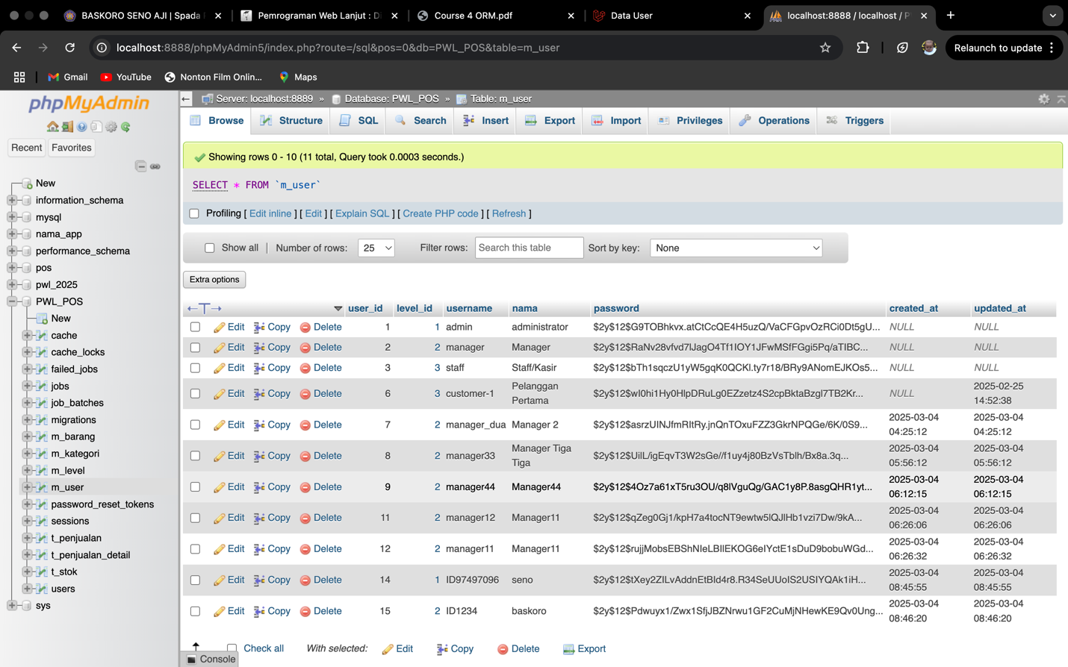

* **Explanations :**  The user_tambah.blade.php view displays a form for adding a new user, using the POST method to send data to '/user/tambah_simpan' while including CSRF protection (@csrf). The form contains input fields for username, nama, password, and level_id, followed by a "Simpan" (Save) button

The Route::get('/user/tambah', [UserController::class, 'tambah']); defines a GET route that loads the user addition form. The tambah() method in UserController renders the user_tambah Blade view. Upon form submission, the tambah_simpan(Request $request) method retrieves user input, saves the data to UserModel, hashes the password before storing it, and redirects to '/user' after saving.

The user_ubah.blade.php view displays a form for updating existing user data. It fetches user details using {{ $data->username }}, {{ $data->nama }}, etc., and submits the update request via the PUT method to '/user/ubah_simpan/{id}'.

The Route::get('/user/ubah/{id}', [UserController::class, 'ubah']); handles GET requests to display the update form, while Route::put('/user/ubah_simpan/{id}', [UserController::class, 'ubah_simpan']); processes the update request. The ubah($id) method retrieves user data based on the provided id and passes it to the user_ubah view. The ubah_simpan($id, Request $request) method finds the user by id, updates their details, hashes the new password before saving, and redirects after successfully storing the changes.

* Step 15-19 :

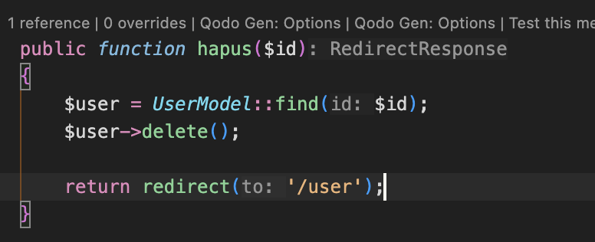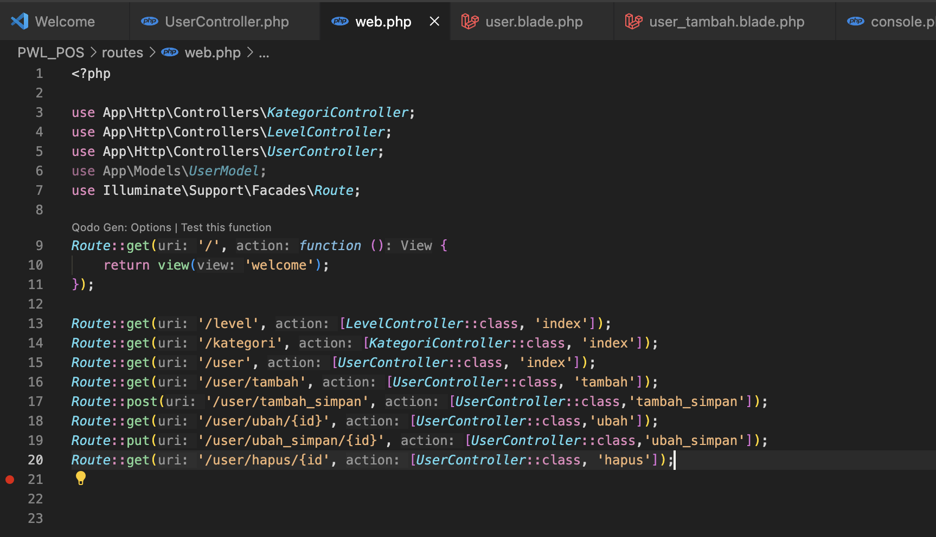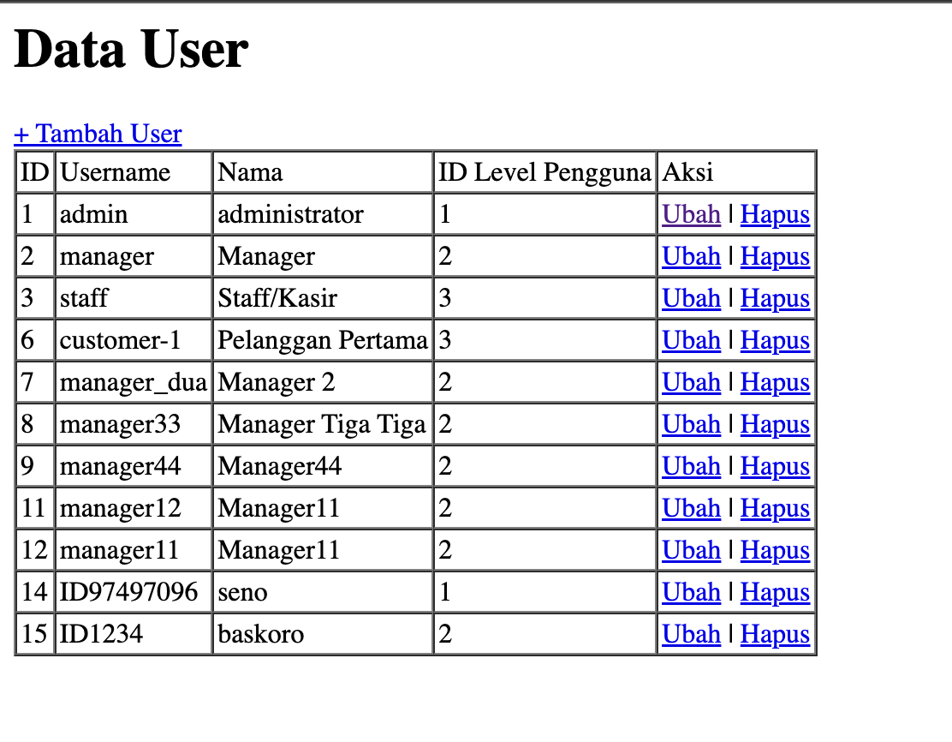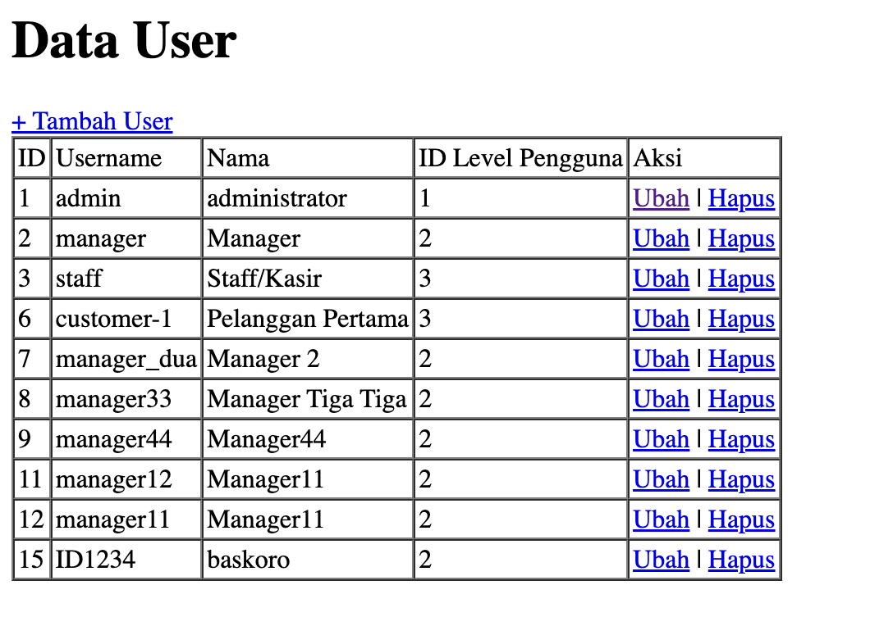

* **Explanations :** The hapus($id) method in UserController is responsible for deleting a user based on the provided id. It first attempts to find the user in UserModel using find($id). If the user exists, it proceeds with the delete() operation; otherwise, it prevents errors by ensuring no action is taken for non-existent id values. After deletion, the method redirects to '/user' to reflect the updated user list.

The Route::delete('/user/hapus/{id}', [UserController::class, 'hapus']); defines a DELETE route, which is the appropriate HTTP method for handling resource deletion requests.

**Praktikum 2.7 Relationship :**

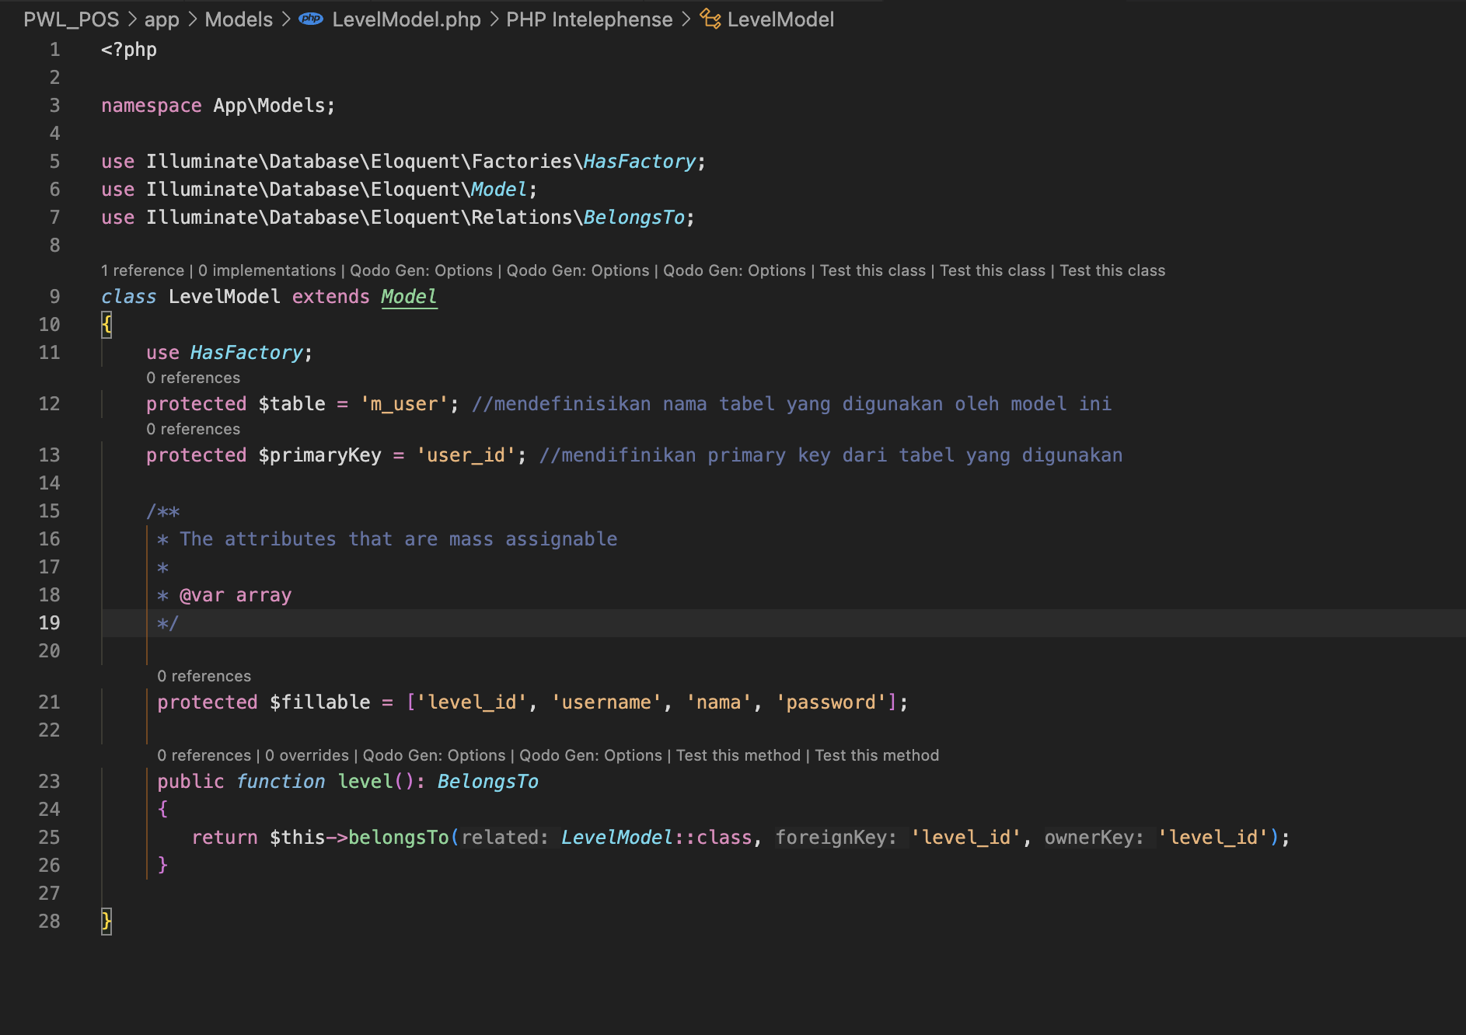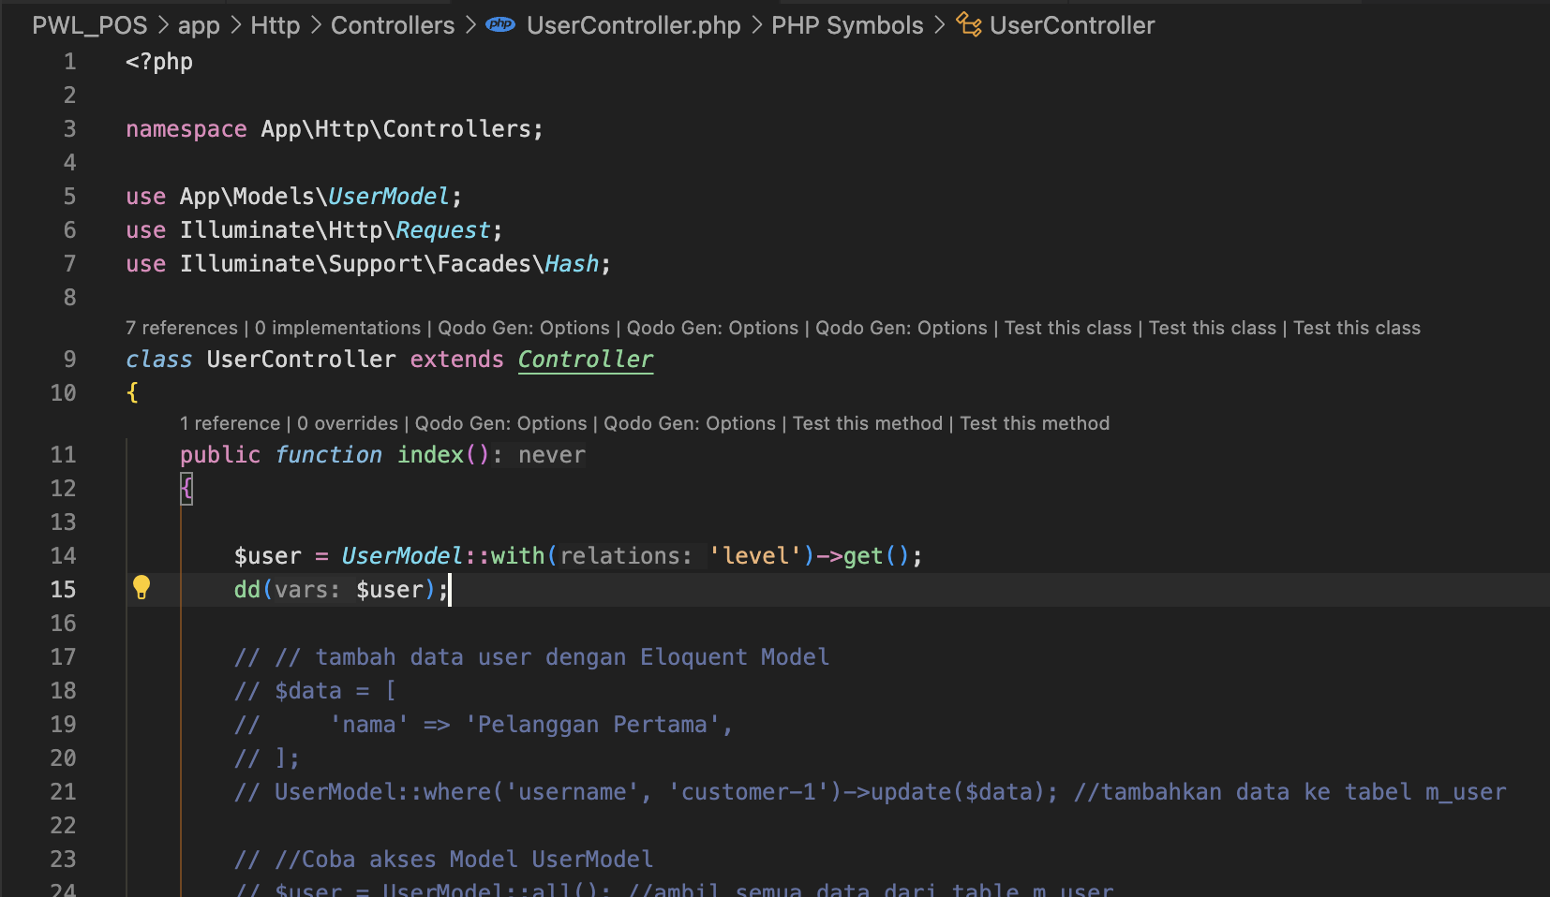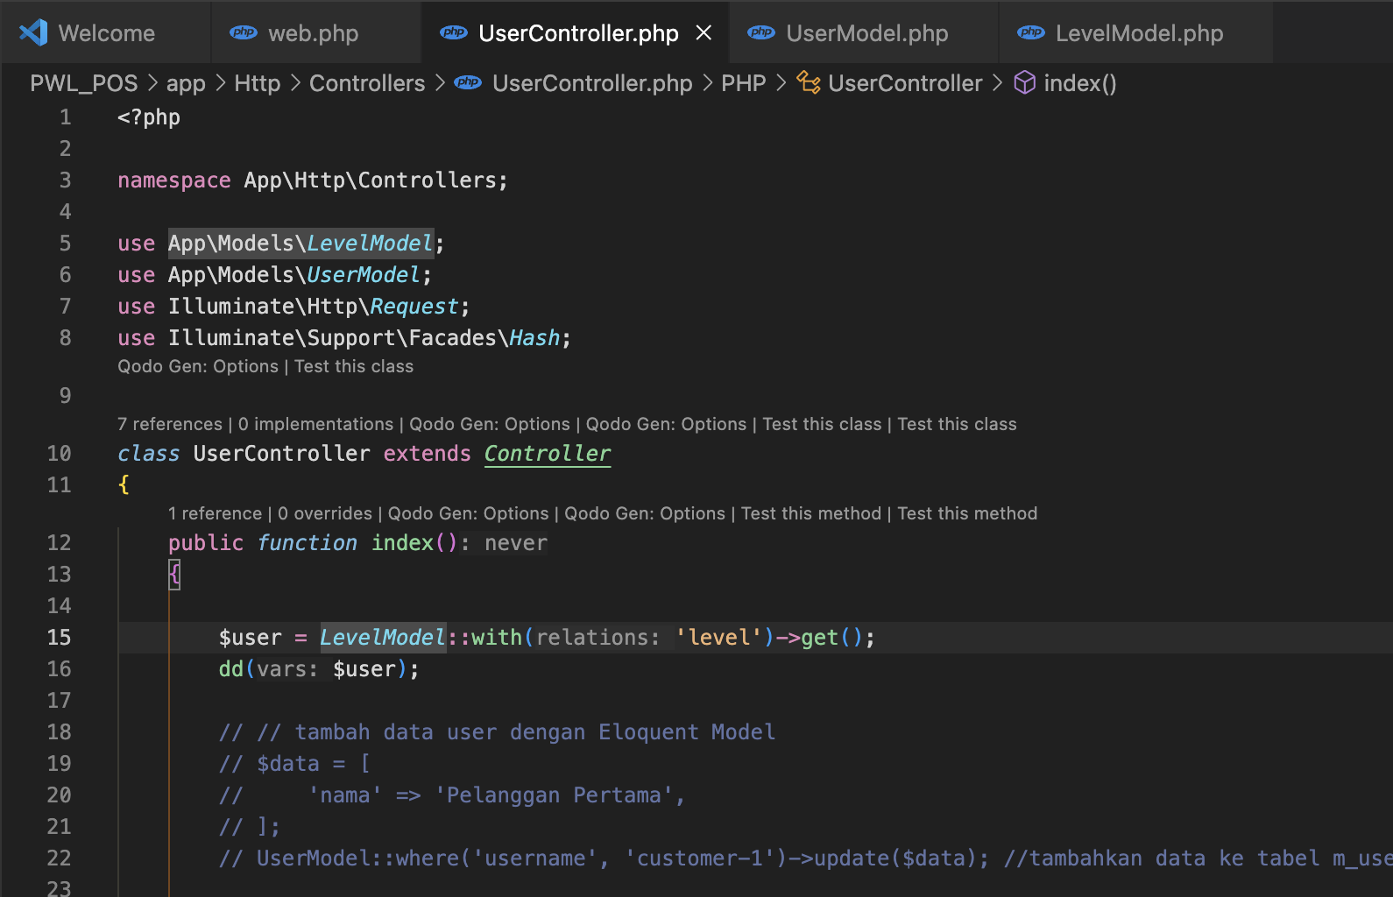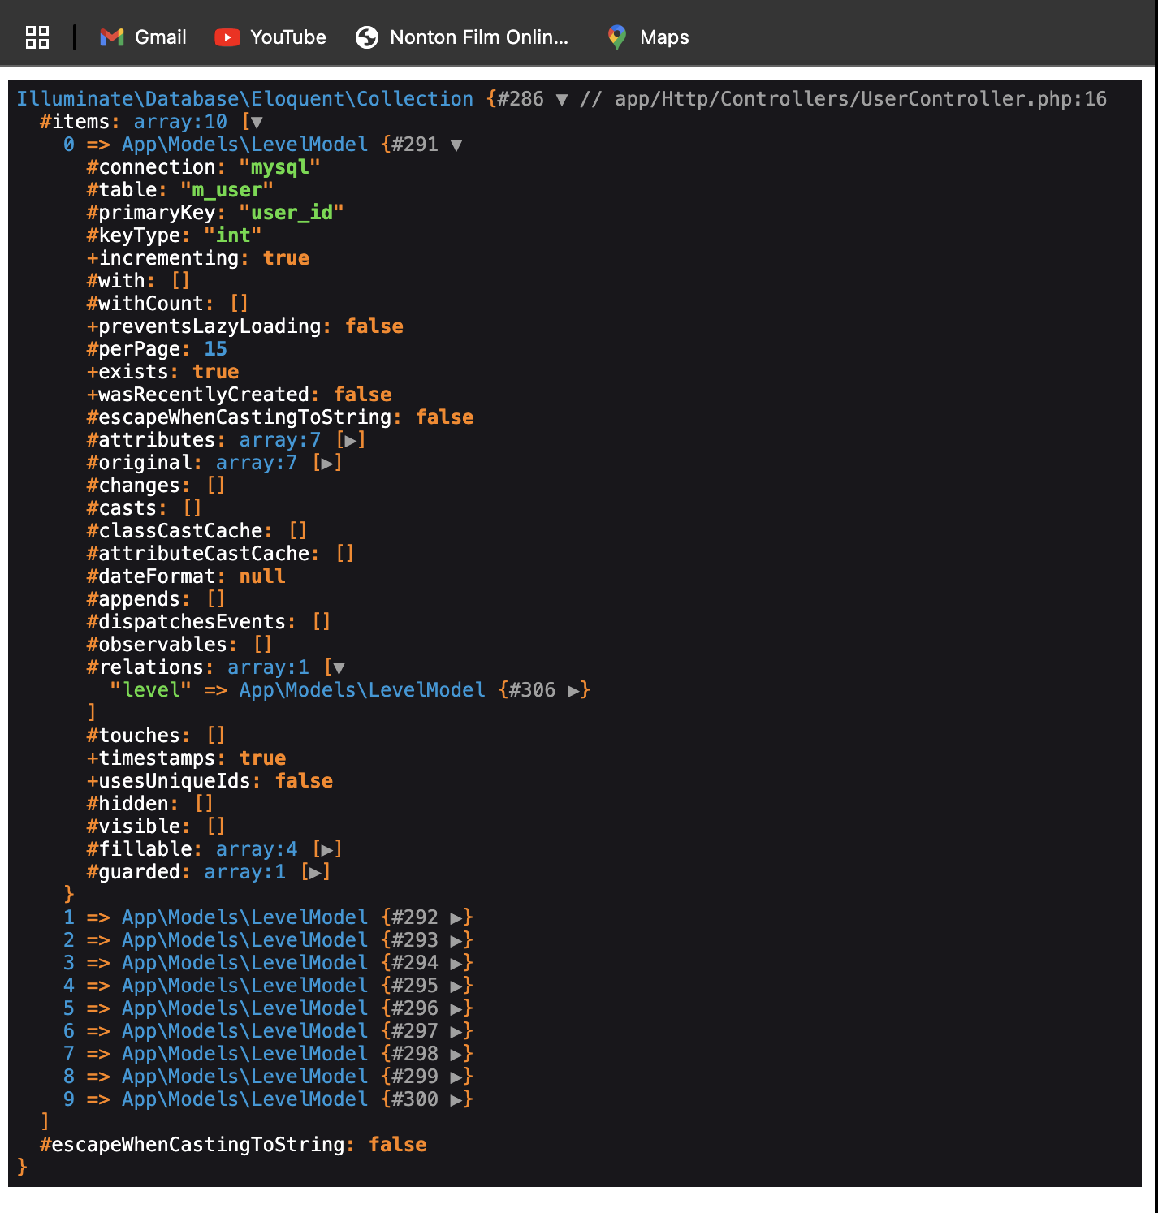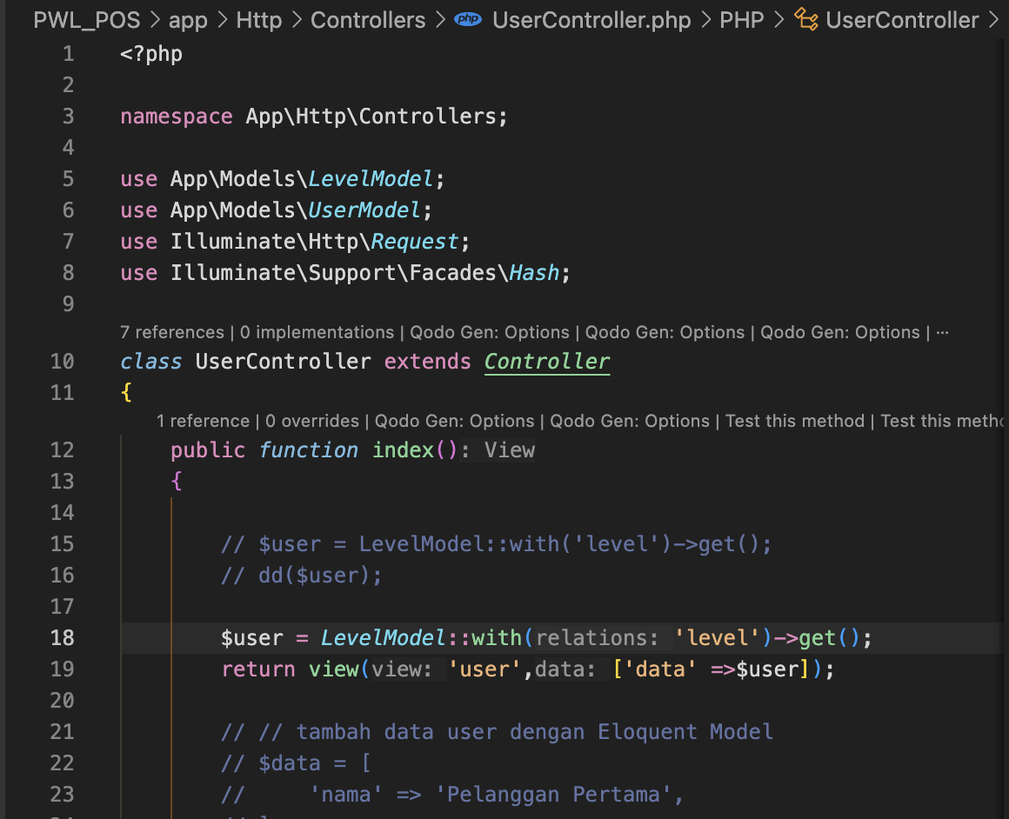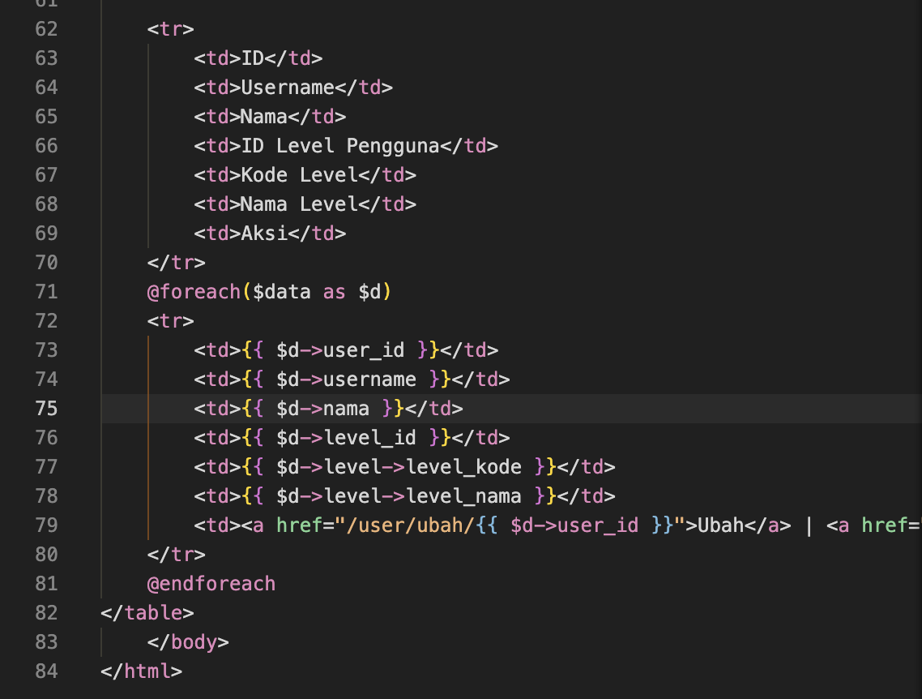

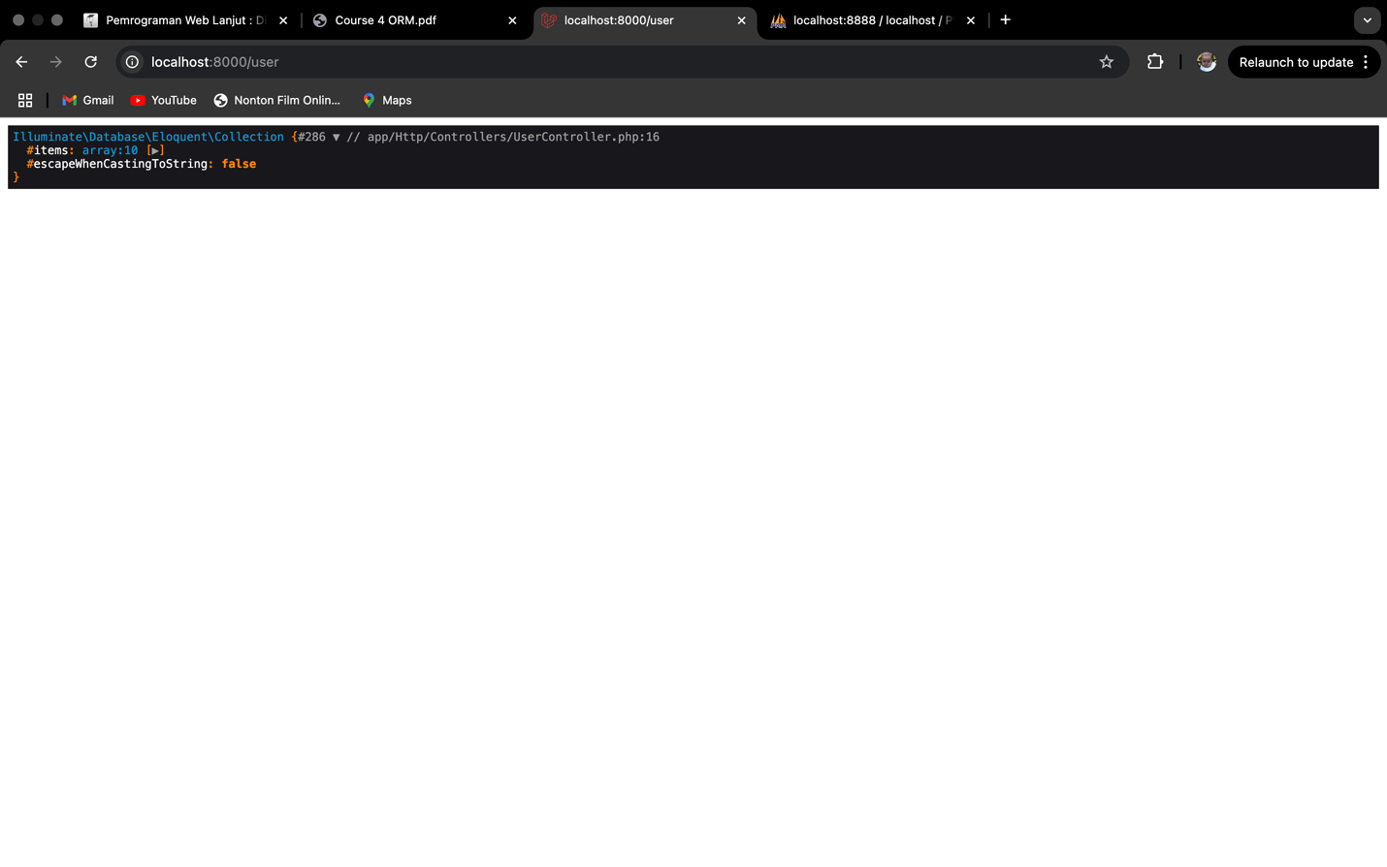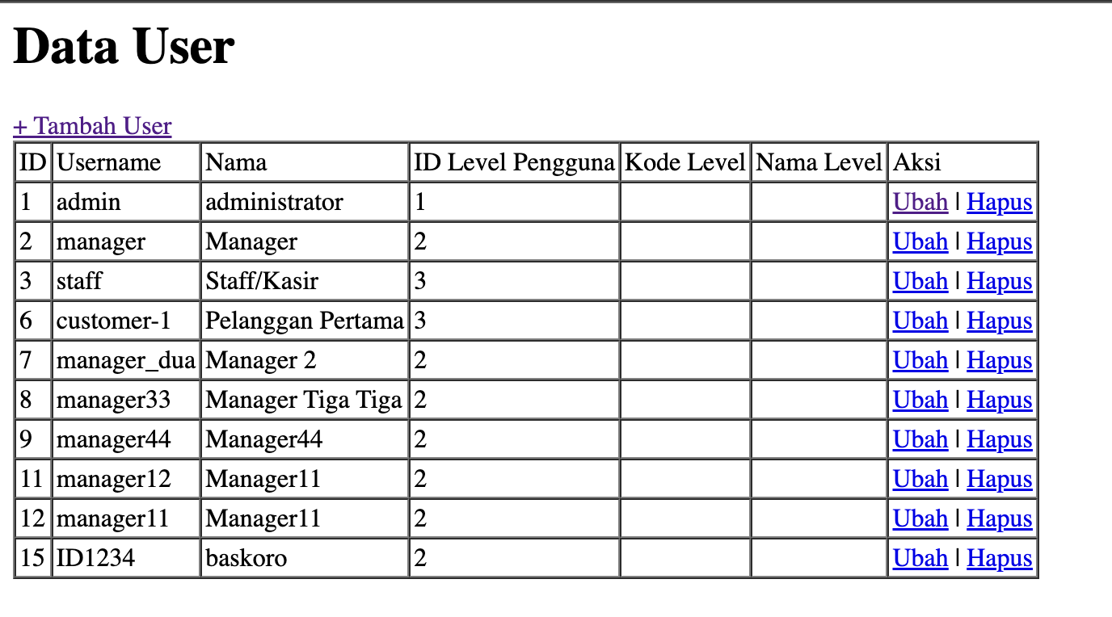

* **Explanations :** the LevelModel and UserModel are structured to represent the m_user table, with UserModel establishing a BelongsTo relationship to LevelModel via level_id. The LevelModel similarly defines a BelongsTo relationship to UserModel, though the table naming may require clarification. The use of eager loading with UserModel::with('level')->get(); optimizes data retrieval by efficiently loading user details along with their associated levels. The dd() function confirms that the relationship is correctly established by displaying the relational data within the retrieved UserModel instances. Finally, the user.blade.php view presents this data in a tabular format, ensuring that user information and their respective levels are clearly displayed.